Blockchain based medical record management system (HealthChain)
By:

Muhammad Qasim 2022-GCUF-063326

PROJECT SUBMITTED IN PARTIAL FULFILLMENT OF THE REQUIREMENTS FOR THE DEGREE OF

BACHELOR OF SCIENCE
IN
COMPUTER SCIENCE


DEPARTMENT OF COMPUTER SCIENCE
GOVERNMENT COLLEGE UNIVERSITY, FAISALABAD
2026
DECLARATION

The work reported in this project was carried out by Muhammad Qasim 2022-GCUF-063326 under the supervision of Madam Sidra. We hereby declare that the “Blockchain based medical record management system” and the content of this project is the product of our own research and no part has been copied from any other source, degree/diploma. The University may take action if the information is founded inaccurate at any stage.

Signature:
Muhammad Qasim
20222-GCUF-063326

ACKNOWLEDGMENT

Words are bound and knowledge is limited to praise GOD ALMIGHTY the beneficent, the merciful who universe and bestowed mankind with the knowledge and ability to think into his secrets. GOD ALMIGHTY has endowed us the techniques of critical analysis up the ideas with fruitful consequences. Then the trembling lips and wet eyes praise the greatest man of universe, the last messenger of ALLAH, HAZRAT MUHAMMAD (PBUH), whom ALLAH has sent as mercy for worlds, the illuminating torch, the blessing for the literate, illiterate, rich, poor, powerful, weaker, and able and disable. Finally, we dedicate this effort to our beloved parents and family members, whose unconditional love, prayers, sacrifices, and endless support have always been the foundation of our achievements. Without their encouragement and belief in us, this accomplishment would not have been possible.
May Allah Almighty accept this humble effort and make it beneficial for humanity. Ameen.

Muhammad Qasim

CERTIFICATE BY SUPERVISORY COMMITTEE

This is to certify that Muhammad Qasim 2022-GCUF-063326 under the supervision of Mam Sidra have successfully completed the final year project named as “Block chain based medical record management system” at Department of Computer Science, (Government Municipal Graduate College Fsd) to fulfill the partial requirement for the degree of Bachelor of Science in Computer Science.

Supervisor
Signature of Supervisor ………………………
Name …………………………………………
Designation with Stamp ………………………

Chairperson:
Signature …………………...…………………
Name …………………………………………
Designation with Stamp ………………………

DEDICATION

To my parents, whose unwavering faith and silent sacrifices made every late night worthwhile.

To my teachers, who taught me not just to write code, but to think deeply about the problems worth solving.

And to every patient in this world who has ever lost a medical record, waited too long for a prescription, or been turned away because a doctor could not access their history — this project is for you.

Muhammad Qasim

TABLE OF CONTENTS
Contents
1. CHAPTER 1: INTRODUCTION TO THE PROBLEM 10
1.1 Introduction 10
1.2 Background 10
1.3 Purpose 11
1.4 Scope 12
1.5 Objectives 12
1.6 Intended Audience and Reading Suggestions 13
1.7 Document Convention 14
2. CHAPTER NO 2: SOFTWARE REQUIREMENT SPECIFICATION. 15
2.1 Overall Description 15
2.1.1 Product Perspectives 15
2.1.2 Product Features 16
2.1.3 Design and Implementation Constraints 16
2.1.4 Assumptions and Dependencies 17
2.2 System Features 17
2.2.1 System Feature 1: Wallet-Based Authentication and Role Detection 17
2.2.2 System Feature 2: Doctor Registration and Admin Verification 18
2.2.3 System Feature 3: Patient Registration 18
2.2.4 System Feature 4: Appointment Booking with Automated Payment Distribution 19
2.2.5 System Feature 5: Medical Record Management 19
2.2.6 System Feature 6: Digital Prescription Issuance 20
2.2.7 System Feature 7: Decentralized Medicine Marketplace 20
2.2.8 System Feature 8: On-Chain Messaging Between Doctors and Patients 21
2.2.9 System Feature 9: Admin Dashboard and Platform Management 21
2.2.10 System Feature 10: AI HealthBot — Intelligent Platform Guide 22
2.3 External Interface Requirements 24
2.3.1 User Interfaces 24
2.3.2 Hardware Interfaces 24
2.3.3 Software Interfaces 24
2.3.4 Communication Interfaces 25
2.4 Other Non-Functional Requirements 25
2.4.1 Performance Requirements 25
2.4.2 Safety Requirements 26
2.4.3 Security Requirements 26
3. CHAPTER 3: ANALYSIS (USE CASE MODEL) 28
3.1 Identifying Actors and use cases using Textual Analysis 28
3.2 Forming Use Case Diagram with Candidate and Use Cases 28
3.3 Describe the Events Flow for Use Case 30
4. CHAPTER NO 4: DESIGN 32
4.2 ERD with Data Dictionary 33
4.3 Data Flow Diagram (Level 0 and Level 1) 34
4.3.1 Data Flow Diagram for Level 0 35
4.7 Activity Diagram 43
4.8 Collaboration Diagram 45
CHAPTER NO 5: IMPLEMENTATION 46
5.1 Component Diagram 46
5.2 Deployment Diagram 47
5.3 Database Architecture (1- Tier, 2-Tier, 3- Tier Architecture) 48
5.3.1 1-Tier Architecture 48
5.3.2 2-Tier Architecture 48
5.3.3 3-Tier Architecture 49
CHAPTER NO 6: TESTING (SOFTWARE QUALITY ATTRIBUTES) 50
6.1 Test Case Specification 50
6.2 Black Box Test Cases 51
6.2.2 Equivalence Class Partitioning 52
6.2.3 State Transition Testing 53
6.2.4 Decision Table Testing 54
6.2.5 Graph Base Testing 54
6.3 White Box Testing 55
6.3.1 Statement Coverage 55
6.3.2 Branch Coverage 55
6.3.3 Path Coverage 55
CHAPTER NO 7: TOOLS AND TECHNOLOGIES 56
7.1 Programming Languages 56
7.2 Operating Environment 57
APPENDIX B: SOURCE CODE 61

LIST OF TABLES

Table 1.5 Objectives 13

Table1.6 Intended 1 15
Table1.6 Intended 2 16

2.2.10 1 29
2.2.10 2 Functional Requirements 30
2.2.10 3 Component Architecture 31
6.2.3 Appointment Lifecycle 1 60

6.2.3 State Transition 1 59

7.1 Language Framerworks 1 64

7.2 Minimum Hardware Requirements 1 65

LIST OF FIGURES

Figure 3.2 Usecase Daigram 1 38

Figure 4.2 ERD Diagram 1 41
Figure 4.2 ERD Diagram 2 42

Figure 4.3.1 Data Flow Diagram 1 43
Figure 4.3.1 Data Flow Diagram 2 45

Figure 4.4 Class Diagram 1 46

Figure 4.5 Object Diagram 1 47
Figure 4 Sequence Diagram 1 48

Figure 4.7 Activity Diagram 1 50

Figure 5 Component Diagram 1 53

Figure 5.2 Deployment Diagram 1 52

Figure Collaboration Diagram 1 51

1. CHAPTER 1: INTRODUCTION TO THE PROBLEM

1.1 Introduction
The management of patient health records, physician credentials, and clinical transactions has long been a challenge in healthcare systems worldwide. As healthcare delivery has grown in complexity, the volume of data generated across hospitals, clinics, pharmacies, and diagnostic centers has increased substantially. Despite the widespread adoption of electronic health record (EHR) systems, these platforms have largely replicated the structural limitations of their paper-based predecessors: data is owned and controlled by individual institutions, interoperability between systems is limited, and patients have minimal visibility into or control over their own health information.

HealthChain is a final-year project that proposes an alternative model. It is a decentralized healthcare management platform built on the Ethereum blockchain. By encoding all core healthcare management logic within a Solidity smart contract, HealthChain eliminates the dependency on any central server or administrative authority. Patient records, appointment data, prescriptions, and financial transactions are recorded on an immutable, distributed ledger that no single party controls. This document serves as the complete technical specification and report for the HealthChain system.

1.2 Background
The global healthcare industry generates approximately 30% of the world's data volume, a figure that continues to grow with the expansion of telemedicine, wearable health monitoring, and genomic medicine. Despite this data abundance, clinical decision-making at the point of care is frequently hampered by the inaccessibility of relevant patient history. A physician consulting a patient at a different hospital than where prior treatment occurred has no reliable means of retrieving prior diagnoses, medication records, or allergy information in real time.

This fragmentation arises from the architecture of conventional healthcare information systems. Each institution operates its own proprietary database, governed by its own data policies, and accessible only to its own credentialed staff. Interoperability standards such as HL7 FHIR have been introduced to bridge these silos, but implementation remains inconsistent and adoption is far from universal.
Blockchain technology offers a structurally different approach. Introduced by Satoshi Nakamoto in 2008 as the underlying ledger mechanism of Bitcoin, blockchain is a distributed, append-only data structure in which records are grouped into cryptographically linked blocks and validated by network consensus. The Ethereum platform, launched in 2015, extended this concept with the smart contract: a deterministic, self-executing program deployed on the blockchain that encodes business rules and executes them automatically when invoked by a transaction. Smart contracts run on the Ethereum Virtual Machine (EVM), a decentralized computing environment that guarantees consistent execution across all nodes in the network.
Healthcare data recorded on a blockchain inherits three properties directly relevant to the problems described above. First, immutability ensures that records cannot be altered after creation, providing a reliable audit trail. Second, transparency allows authorized parties to verify record authenticity without trusting a central authority. Third, decentralization eliminates single points of failure and reduces the concentration of sensitive data in high-value attack targets.

1.3 Purpose
The purpose of the HealthChain project is to demonstrate the technical feasibility of a blockchain-based healthcare management system that addresses the structural limitations of centralized platforms. Specifically, the system is designed to show that a smart contract can serve as the sole source of truth for healthcare data management — eliminating the need for a centralized database server while preserving the core functions expected of a healthcare information platform.
The secondary purpose is to produce a working prototype that can be evaluated against academic software engineering standards, including requirements specification, system design through UML modeling, implementation using industry-standard tools, and systematic testing. The project is intended to fulfill the requirements of the Final Year Project submission for the Bachelor of Science in Computer Science program.

1.4 Scope
User Interface (UI) Components:
The HealthChain system is bounded by the following scope:
In Scope:
The system supports three user roles: Administrator, Doctor, and Patient. All role management, data storage, and financial transactions are handled by a single Solidity smart contract deployed on a Hardhat local Ethereum network (Chain ID 31337). The system includes: wallet-based authentication via MetaMask, doctor registration with IPFS credential storage, patient registration with automatic consultant assignment, appointment booking with automatic ETH payment distribution, on-chain medical record management, digital prescription issuance, a medicine marketplace with discount logic, peer-to-peer on-chain messaging, an administrative dashboard with revenue withdrawal capability, and an AI-powered onboarding assistant (HealthBot) powered by the Groq API.
Out of Scope:
The system does not include integration with any external Electronic Health Record system, real-time video consultation, mobile application development, deployment to a public Ethereum network or mainnet, multi-administrator governance, or HIPAA/GDPR compliance certification. These areas are identified as candidates for future development.

1.5 Objectives
The objectives of the HealthChain project are as follows:
Table 1.5 Objectives

Obj. No. | Objective
O-01 | To design and deploy a Solidity smart contract encoding all core healthcare management logic on the Ethereum blockchain.

O-02 | To implement wallet-based authentication using the MetaMask browser extension, replacing password-based access control.
O-03 | To develop a role-based Next.js frontend that renders appropriate interfaces for Administrator, Doctor, and Patient roles.
O-04 | To integrate IPFS via the Pinata pinning service for decentralized storage of medical certificates and profile images.
O-05 | To implement a transparent on-chain economic model governing consultation fees, medicine purchases, and platform revenue.
O-06 | To enable permanent, verifiable peer-to-peer messaging between physicians and patients stored on the blockchain.
O-07 | To provide an AI-powered conversational assistant (HealthBot) to reduce the onboarding barrier for non-technical users.
O-08 | To evaluate the system through structured black box and white box testing against defined test cases.

1.6 Intended Audience and Reading Suggestions
This document is intended for the following audiences:
Audience | Relevant Sections
Academic Evaluators and Project Supervisors | All chapters — particularly Chapters 2, 3, 4, and 6
Software Developers and Technical Reviewers | Chapters 4, 5, 7, and Appendix B (Source Code)
Healthcare Domain Experts | Chapters 1, 2, and 3
Non-Technical Readers | Chapter 1 and Appendix A (User Documentation)
Table1.6 Intended 1
It is recommended that academic evaluators read the chapters sequentially. Developers may refer directly to Chapter 4 (Design) and Chapter 5 (Implementation) after reviewing the Software Requirements Specification (SRS) in Chapter 2. Non-technical readers should consult Appendix A for a simplified guide to the platform.

1.7 Document Convention
This document follows the IEEE 830 Software Requirements Specification (SRS) standard for the structure of Chapter 2. The following conventions are used throughout the document:
Convention | Meaning
SHALL | Mandatory requirement — the system must implement this without exception
SHOULD | Recommended requirement — preferred but not strictly mandatory
MAY | Optional feature — may be implemented at the developer’s discretion
FR-x.y | Functional Requirement identifier (Feature number . Requirement number)
NFR-x.y | Non-Functional Requirement identifier
[Figure x.y] | Reference to a diagram listed in the List of Figures
Italics | Technical terms introduced for the first time
code font | Source code identifiers, function names, and file paths
Table1.6 Intended 2
All monetary values in the system are denominated in Ether (ETH) and wei (1 ETH = 10¹⁸ wei). All timestamps are recorded as Unix epoch values using Ethereum block timestamps.

2. CHAPTER NO 2: SOFTWARE REQUIREMENT SPECIFICATION.

2.1 Overall Description
This section provides a high-level overview of the HealthChain Decentralized Application (DApp). It outlines the product's perspective, main features, and the constraints and dependencies under which it operates, providing a foundational understanding of how this blockchain-based healthcare system functions.

2.1.1 Product Perspectives
HealthChain is a standalone, self-contained decentralized application. It does not extend or integrate with any existing healthcare software system. Instead, it is a complete replacement model — a greenfield solution that demonstrates how an entire healthcare management ecosystem can be operated exclusively on a blockchain without any traditional server-side infrastructure.
The system architecture is organized into three distinct layers that work together to deliver the complete user experience. The outermost layer is the Presentation Layer, which consists of a Next.js 14 web application running in the user's browser. This layer is responsible for rendering dashboards, forms, and interactive interfaces for all three roles. It communicates with the blockchain through the Ethers.js library, which translates JavaScript function calls into Ethereum transactions and contract reads. The middle layer is the Blockchain Layer, which consists of the Healthcare.sol Solidity smart contract deployed on an Ethereum-compatible network. This contract holds all application state — every doctor, patient, appointment, medical record, prescription, medicine, and message — and enforces all business rules through on-chain logic. The third layer is the Storage Layer, which uses IPFS through the Pinata pinning service. When a user uploads a profile image, medical certificate, or any document, the file is sent to Pinata's API, pinned on the IPFS network, and its CID is returned to the frontend. Only this CID is then stored on-chain in the smart contract, keeping gas costs low while ensuring the file remains accessible through any IPFS gateway.
The smart contract is deployed at a fixed address configured in the frontend at client/config/index.js. The contract ABI (Application Binary Interface) is imported from the compiled Hardhat artifact, allowing the frontend to know exactly which functions are available and what parameters they accept. Wallet authentication is handled entirely through MetaMask: when a user connects their wallet, the frontend reads their Ethereum address and queries the contract to determine whether they are the admin, a registered doctor, a registered patient, or an unregistered user, and routes them accordingly.

2.1.2 Product Features
HealthChain provides ten major functional capabilities. The first is wallet-based authentication, where users log in using their MetaMask Ethereum wallet and are automatically identified by their on-chain role. The second is doctor registration and admin-controlled KYC verification, allowing qualified professionals to join the platform with their credentials stored on IPFS and verified by the admin on-chain. The third is patient registration with the selection of a verified general consultant doctor. The fourth is appointment booking, where patients pay doctors in ETH directly through the smart contract with automated fee distribution. The fifth is medical record management, allowing verified doctors to add immutable, time-stamped clinical records for their patients. The sixth is digital prescription issuance, where doctors prescribe active medicines from the marketplace to specific patients on-chain. The seventh is the medicine marketplace, where the admin lists medicines and patients purchase them by paying ETH with real-time stock tracking. The eighth is on-chain messaging between verified doctors and registered patients through a deterministic chat room system. The ninth is the admin dashboard for managing doctor verifications, medicine inventory, and platform revenue. The tenth is IPFS-backed decentralized file storage for all profile images, certificates, and documents.

2.1.3 Design and Implementation Constraints
Several constraints govern the design and implementation of HealthChain that developers and evaluators must be aware of. The most fundamental constraint is blockchain dependency: every state-changing operation in the system requires an active connection to an Ethereum node and incurs a gas fee. This means users must hold ETH in their wallet not only for payments but also to cover transaction costs for registration and record updates.
The system is also constrained by its exclusive reliance on MetaMask as the wallet provider. The frontend detects window.ethereum injected by MetaMask; no other wallet adapter is integrated in the current implementation. This limits the system to desktop browsers where MetaMask is installed.
Smart contract immutability is another significant constraint. Once the Healthcare.sol contract is deployed to the Ethereum network, its logic cannot be modified. Any changes to business rules, data structures, or access control would require redeployment of a new contract and reconfiguration of the frontend to point to the new address. All previously accumulated data on the old contract would need to be migrated manually.
On-chain data storage is expensive on Ethereum, which constrains the system to store only small data directly in contract state — addresses, strings, integers, and booleans. All large binary data such as images and documents must go through IPFS, adding a dependency on the Pinata API. If Pinata's service is unavailable, file uploads will fail. API keys for Pinata are stored in Next.js environment variables with the NEXT_PUBLIC_ prefix, making them visible in the browser bundle — a known tradeoff for a purely client-side DApp architecture.
Because Next.js supports server-side rendering (SSR), all Web3 interactions that use window.ethereum must be wrapped in "use client" directives and run exclusively in the browser context. Server-side rendering of blockchain data is not supported without a dedicated backend node.
Finally, the admin role is permanently assigned to the deployer's wallet address at contract construction time and cannot be transferred or shared. There is no multi-signature governance mechanism in the current version.

2.1.4 Assumptions and Dependencies

This specification assumes that all users of the system have access to a modern web browser — specifically Google Chrome or Mozilla Firefox — with the MetaMask browser extension installed and configured with at least one Ethereum account. It is assumed that the Ethereum network to which the contract is deployed (whether a local Hardhat node or a public testnet such as Sepolia) is running and reachable during all user sessions.
It is assumed that patients must always select a verified doctor as their general consultant during registration; if no verified doctors exist on the platform, patient registration cannot proceed. Consultation fees and medicine prices in the smart contract are denominated in Wei, and it is assumed that all financial interactions are conducted in ETH or its sub-units with no fiat currency integration.
The system depends on Hardhat for local development, testing, and contract deployment. It depends on Ethers.js v6 for all blockchain interactions in the frontend. It depends on Pinata's REST API for IPFS file pinning. The frontend is built on Next.js 14 using the App Router paradigm, and the UI components are drawn from the shadcn/ui component library built on Tailwind CSS. Framer Motion is used for UI animations, and Lucide React provides the icon set. All of these are listed as dependencies in client/package.json.

2.2 System Features

2.2.1 System Feature 1: Wallet-Based Authentication and Role Detection
This feature allows users to securely authenticate with the HealthChain platform using their MetaMask Ethereum wallet without any username, password, or session token. When a user clicks "Connect Wallet" on the landing page, the system calls the MetaMask provider to request access to the user's Ethereum accounts. Once access is granted, the connected address is stored in the application's Web3 context. The system then queries the smart contract to determine the user's role: it checks whether the address equals the admin's address, whether doctors[address].isRegistered is true, or whether patients[address].isRegistered is true. Based on this check, the user is automatically routed to the Admin Dashboard, Doctor Dashboard, Patient Dashboard, or shown a role selection screen if they are not yet registered.
The system must detect whether MetaMask is installed and display an informative error message if window.ethereum is not found. If the wallet connection fails or is rejected by the user, an error state must be displayed with an option to retry. Once connected, the user's wallet address is displayed in abbreviated form throughout the UI to confirm their active identity. All role checks are performed by reading from the blockchain, ensuring that no frontend-side privilege can be assumed without genuine on-chain registration.

2.2.2 System Feature 2: Doctor Registration and Admin Verification
This feature enables medical professionals to register on the HealthChain platform by submitting their professional credentials through the frontend, which then calls the registerDoctor() function on the smart contract. During registration, the doctor provides their full name, medical specialization, years of experience, consultation fee (in Wei), available consultation hours, and uploads both a profile photograph and a medical certificate. The frontend uploads these two files to IPFS via the Pinata API and retrieves their CIDs, which are then passed as profileImageURI and certificateURI to the smart contract. The doctor must also send a registration fee in ETH with the transaction, which is stored as platform revenue. Attempting to register from an already-registered wallet address will cause the transaction to revert.
After registration, the doctor's isVerified flag is set to false. The doctor cannot access clinical features — updating records, prescribing medicines, completing appointments — until the admin reviews their credentials and calls verifyDoctor(doctorAddress, true). The admin can also revoke verification by calling the same function with false. This on-chain KYC mechanism ensures that only credentialed and approved professionals provide medical services through the platform.

2.2.3 System Feature 3: Patient Registration
This feature allows individuals to register as patients on the platform by submitting their personal and medical information through the Patient Registration form. The patient provides their full name, age, blood group, known allergies, current medications, and uploads a profile image to IPFS. Crucially, the patient must select a verified doctor from the platform to serve as their general consultant. This selection is mandatory and validated on-chain: the smart contract checks that doctors[generalConsultant].isVerified is true before allowing registration to proceed. If no verified doctors exist, registration will fail.
The smart contract stores all patient data under the patient's wallet address in the patients mapping and pushes the address to the patientAddresses array. Each wallet address may only register as a patient once. Upon successful registration, the patient gains access to the Patient Dashboard, where they can view their medical history, book appointments, manage prescriptions, purchase medicines, and message their doctor.

2.2.4 System Feature 4: Appointment Booking with Automated Payment Distribution
This feature allows registered patients to book consultations with any verified doctor by paying the doctor's consultation fee in ETH through the smart contract's bookAppointment() function. The patient specifies the doctor's address, the preferred appointment time, and an optional note. The patient must send ETH equal to or greater than the doctor's registered consultationFee. The smart contract automatically calculates a 10% platform commission on the fee, transfers the remaining 90% directly to the doctor's wallet using Solidity's transfer() function, and adds the 10% to the platformRevenue counter. Any ETH sent in excess of the consultation fee is immediately refunded to the patient.
The appointment is recorded on-chain with a unique auto-incremented ID, storing the patient address, doctor address, time, note, and a completion status flag initialized to false. The appointment ID is added to both doctorAppointments[doctorAddress] and patientAppointments[patientAddress] mappings, enabling either party to retrieve their appointment history. When the consultation is complete, the verified doctor calls completeAppointment(appointmentId) to mark it as done on-chain.

2.2.5 System Feature 5: Medical Record Management
This feature enables verified doctors to create permanent, immutable medical records for their registered patients on the blockchain. After completing a consultation, the doctor can call updateMedicalRecord(patientAddress, diagnosis, medicalHistory) to append a new record to the patient's on-chain medical history. The function verifies that the caller is a verified doctor and that the target is a registered patient before writing the data. Each record stores the patient's address, the treating doctor's address, the diagnosis text, the medical history narrative, and a block.timestamp that provides a tamper-proof record of when the entry was created.
Medical records are stored in an array under patientRecords[patientAddress] and can only be appended, never deleted or modified, preserving a complete and auditable clinical history. Records can be retrieved through getPatientMedicalHistory(patientAddress), which is access-controlled to allow reads only by the patient themselves or by any verified doctor. This feature forms the core of the system's value proposition — an inviolable, blockchain-backed medical history that follows the patient regardless of which hospital or doctor they visit next.

2.2.6 System Feature 6: Digital Prescription Issuance

This feature allows verified doctors to issue digital prescriptions to registered patients on-chain by calling prescribeMedicine(patientAddress, medicineId, dosageInstruction, quantity). The function first validates that the calling doctor is verified and that the patient is registered. It then checks that the referenced medicine ID is active in the marketplace before creating the prescription record. Each prescription stores the patient and doctor addresses, the medicine ID, dosage instructions, quantity, and a blockchain timestamp.
Prescriptions are stored in patientPrescriptions[patientAddress] as an append-only array. They can be retrieved through getPatientPrescriptions(patientAddress), accessible only by the patient or a verified doctor. Because prescriptions reference active medicine IDs from the on-chain marketplace, there is a built-in guarantee that every prescribed medicine is a real, admin-approved pharmaceutical listed in the system. Patients can then use their prescription information to purchase the exact medicine from the marketplace feature.

2.2.7 System Feature 7: Decentralized Medicine Marketplace

This feature implements a fully on-chain medicine marketplace where the admin populates the inventory and registered patients make purchases in ETH. The admin calls addMedicine() with the medicine name, manufacturer, category, dosage, price in Wei, initial stock quantity, discount percentage (0–100), side effects description, and an IPFS URI for the medicine image. The medicine is stored in the medicines mapping under an auto-incremented ID and marked as active.
Patients purchase medicines by calling buyMedicine(medicineId, quantity) and sending ETH with the transaction. The contract calculates the final price as (price × quantity) × (1 − discount / 100) entirely on-chain, ensuring pricing cannot be manipulated by the frontend. If the patient sends insufficient ETH, the transaction reverts. If they send excess ETH, the surplus is refunded. On a successful purchase, the medicine's stockQuantity is decremented; if stock is insufficient, the transaction reverts. All purchase revenue is accumulated in platformRevenue, which the admin can withdraw at any time. This marketplace demonstrates that commerce, inventory management, and financial settlement can all be conducted without any payment processor or backend server.

2.2.8 System Feature 8: On-Chain Messaging Between Doctors and Patients

This feature provides a direct communication channel between verified doctors and registered patients through on-chain messages. Either party initiates a conversation by calling sendMessage(receiverAddress, content). The contract validates that the sender-receiver pair is a legitimate doctor-patient combination — either the sender is a verified doctor and the receiver is a registered patient, or vice versa — before storing the message. This access control prevents spam and unauthorized messaging between unrelated wallets.
Messages are organized into chat rooms identified by a deterministic bytes32 hash computed from the two participants' addresses in a canonical order (keccak256(sorted addresses)). This ensures that both the doctor calling getMessages(patientAddress) and the patient calling getMessages(doctorAddress) retrieve the same shared conversation. Each message stores the sender's address, the receiver's address, the text content, and a block timestamp. While on-chain messaging incurs gas costs per message, it provides the highest possible level of immutability and ensures that no message can be secretly deleted or altered after it has been sent.

2.2.9 System Feature 9: Admin Dashboard and Platform Management
The admin is the wallet address that deployed the smart contract. The onlyAdmin Solidity modifier enforces this at the contract level, making it impossible for any other address to call admin-restricted functions regardless of what the frontend displays. Through the admin dashboard, the platform operator can perform four major functions.
First, the admin reviews doctor registrations and calls verifyDoctor(address, true) to approve or verifyDoctor(address, false) to revoke a doctor's verified status, directly gating access to all clinical features. Second, the admin adds medicines to the marketplace by submitting a form that calls addMedicine() with all required parameters. Third, the admin can view platform statistics — total doctors, patients, medicines, appointments, and accumulated revenue — by calling getPlatformStats(), a view function restricted to the admin. Fourth, the admin calls withdrawPlatformRevenue() to transfer all accumulated platform earnings (from doctor registration fees, appointment commissions, and medicine sales) to the admin wallet. The revenue counter is reset to zero after withdrawal, and the transfer is executed trustlessly by the smart contract with no external payment system involved.

2.2.10 System Feature 10: AI HealthBot — Intelligent Platform Guide
Description and Priority: MEDIUM–HIGH
HealthBot is an AI-powered conversational assistant embedded as a floating widget on every page of the HealthChain platform. It addresses the usability challenges that blockchain applications often present to first-time users who may be unfamiliar with wallet connection, gas fees, and transaction confirmation processes. The assistant uses the LLaMA 3.1 8B Instant model through the Groq Cloud API. All inference requests are processed server-side to ensure that API credentials remain secure and inaccessible to clients.
Stimulus / Response Sequences
Seq. | Stimulus | System Response
1 | User clicks the HealthBot floating button | Chat window opens with a pre-composed welcome message and three quick-reply chips.
2 | User selects a quick-reply chip or types a query | Message is sent via HTTP POST request to /api/groq-chat. The server injects the system prompt, calls the Groq SDK, and returns the AI-generated response.
3 | User asks about doctor onboarding | HealthBot explains the four-step onboarding workflow: form submission, certificate upload, fee payment, and administrator verification.
4 | User asks about wallet connection | HealthBot provides step-by-step MetaMask installation and wallet connection instructions.
5 | Groq API service becomes unavailable | HealthBot displays a graceful fallback message while ensuring that core application functionality remains unaffected.
2.2.10 1
2 0
Functional Requirements
Req. ID | Requirement | Priority
FR-10.1 | The HealthBot toggle button SHALL be visible on every page. | High
FR-10.2 | HealthBot SHALL display a welcome message on first open without initiating any API request. | High
FR-10.3 | All user messages SHALL be sent to /api/groq-chat using a server-side Next.js API route. | High
FR-10.4 | The GROQ_API_KEY SHALL reside exclusively within server-side environment variables. | High
FR-10.5 | The AI model SHALL be restricted to HealthChain platform-related topics using a system-level prompt. | High
FR-10.6 | HealthBot SHALL gracefully handle API failures without affecting the core system functionality. | High
FR-10.7 | HealthBot SHALL NOT require wallet connection or direct blockchain interaction. | High
2.2.10 2 Functional Requirements

Component Architecture
Component | File Location | Responsibility
Chatbot.jsx | client/components/Chatbot.jsx | Implements the floating chatbot user interface
route.js | client/app/api/groq-chat/route.js | Handles secure server-side communication with the Groq API
layout.js | client/app/layout.js | Renders the HealthBot globally across all pages
2.2.10 3 Component Architecture

2.3 External Interface Requirements

2.3.1 User Interfaces
The HealthChain platform implements four distinct interface contexts:
Admin Interface (/admin): A statistics dashboard displaying total registered doctors, patients, listed medicines, and accumulated revenue. Includes a doctor verification panel, a medicine management panel, and a revenue withdrawal control.

Doctor Interface (/doctor): A clinical workspace presenting pending and completed appointments, an assigned patient list, a medical record editor, a prescription issuance form, and the messaging interface.

Patient Interface (/patient): A health management portal presenting the patient's profile, verified doctor directory with booking, medicine marketplace, medical history viewer, prescription history viewer, and messaging interface.
HealthBot Widget (Global):A floating AI chat widget accessible via a persistent toggle at the bottom-right of every page. (Refer to Section 2.2.10)

2.3.2 Hardware Interfaces
HealthChain has no direct hardware interface requirements beyond a standard personal computer or laptop capable of running a modern web browser. The system does not interface with any medical device hardware, biometric scanners, or IoT sensors. Ethereum node interaction is fully abstracted through the MetaMask browser extension, which manages all cryptographic signing operations internally on the user's device.

2.3.3 Software Interfaces
The frontend interfaces with the smart contract through Ethers.js v6, using the compiled ABI stored in client/config/Healthcare.json and the deployed contract address stored in client/config/index.js. All file uploads are sent to the Pinata REST API using HTTPS POST requests authenticated with the PINATA_JWT environment variable. The Pinata gateway URL, also stored as an environment variable, is used to construct full IPFS file URLs from CIDs for display in the frontend. The Next.js application runs in the browser and communicates with MetaMask through the injected window.ethereum provider object.

2.3.4 Communication Interfaces
All communication between the frontend and the IPFS pinning service occurs over HTTPS to the Pinata API endpoints. Communication between the frontend and the Ethereum blockchain occurs via JSON-RPC, which MetaMask manages by routing requests to the configured Ethereum network — either a local Hardhat node (typically at http://127.0.0.1:8545) or a public testnet endpoint. No custom backend server, REST API, or WebSocket server is operated by the HealthChain application itself; all data flows directly between the browser, MetaMask, the Ethereum node, and the Pinata API.

2.4 Other Non-Functional Requirements

2.4.1 Performance Requirements
For HealthChain to be practical for daily medical use, it needs to be reasonably fast and handle data smoothly. We've set a few benchmarks to ensure a good user experience:
Frontend Speed: The main Next.js interface should be fully loaded and ready to use within 3 seconds on a standard internet connection.
Reading from the Blockchain: When the system fetches data (like a patient's history or a list of doctors), it uses Solidity `view` functions. Since these don't require gas or mining, we expect them to return results within 2 seconds from our local Hardhat node.
Writing to the Blockchain: Any action that changes data—like booking an appointment—takes a bit longer. To keep users informed, the UI will immediately show a loading spinner, and the final confirmation should reflect within 5 seconds on the local network.
File Uploads:Uploading medical certificates or profile pictures to IPFS via Pinata should ideally wrap up within 30 seconds for files up to 5 MB.
Handling Growth (Scalability): As the platform grows, lists like `doctorAddresses` and `patientAddresses` will get larger. Because functions like `getAllDoctors()` have to iterate through these arrays on-chain, their speed is tied to the array size. The system is designed to keep functioning correctly and efficiently even when these arrays contain hundreds of records.

2.4.2 Safety Requirements
In any healthcare system, keeping patient data and user funds safe is the absolute top priority. HealthChain handles safety largely through the inherent nature of smart contracts:
Permanent Medical Records (Immutability): We store all medical records and prescriptions in append-only arrays on the blockchain. This means once a doctor writes a prescription or adds a diagnosis, it’s permanent. Nobody—not the doctor, the patient, or even the admin—can delete, overwrite, or quietly change it later. This guarantees a completely trustworthy and verifiable clinical history.
Failing Safely (Reverts): Before any major action happens, the smart contract checks the rules. Is the user authorized? Did they send enough ETH? If any check fails, the contract uses the `require()` statement to instantly cancel (revert) the transaction. This prevents partial or broken updates, meaning if something goes wrong, the system state remains untouched.
Safe Handling of Funds: If a patient accidentally sends more ETH than needed for a consultation or medicine, they won't lose it. The contract logic automatically calculates the exact fee and refunds the extra ETH right back to the sender within the very same transaction.
User Awareness: No hidden actions can happen. Before any transaction goes through, the MetaMask extension pops up to show exactly what is being approved and how much it will cost, keeping the user in control at all times.

2.4.3 Security Requirements
HealthChain takes a different approach to security compared to traditional web apps. Instead of relying on a central database with usernames and passwords, it leans entirely on Ethereum's cryptographic security:
No Passwords or Keys Stored: The application server literally knows nothing about your private keys or seed phrases. You never type a password into our website. All the cryptographic signing happens safely inside the MetaMask wallet on your own device.
Strict On-Chain Access Control: Sensitive information like medical histories and prescriptions are locked down at the contract level. For example, if someone tries to call `getPatientMedicalHistory()`, the contract checks if they are either the specific patient or their verified doctor. If not, it blocks the request immediately, making unauthorized data scraping impossible.
Fixed Admin Powers: To stop hackers from taking over the platform, the admin role is permanently linked to the address that originally deployed the contract. It cannot be transferred or reassigned later.
Secure Fund Withdrawals: The accumulated platform fees can only be withdrawn by the admin. We enforce this with an `onlyAdmin` modifier on the withdrawal function, ensuring no one else can touch the revenue.
Private P2P Messaging: The chat system keeps messages completely isolated. Each conversation happens in a unique "room" whose ID is mathematically generated from the two participants' addresses. This guarantees that messages don't leak over into unrelated chats.
API Key Protection: While the system is decentralized, it still talks to a few APIs like Pinata for IPFS storage. We keep these sensitive API keys safely tucked away in server-side environment variables (`.env.local`), ensuring they never get bundled into the client-side code where someone could steal them.

3. CHAPTER 3: ANALYSIS (USE CASE MODEL)

3.1 Identifying Actors and use cases using Textual Analysis
Admin: The deploying wallet address becomes the platform administrator. The admin is responsible for verifying doctor credentials, managing the medicine marketplace, monitoring platform statistics, and withdrawing accumulated platform revenue. There is exactly one admin per deployed contract instance.
Doctor: A medical professional who registers on the platform by paying a registration fee in ETH and uploading their profile and certificate to IPFS. Doctors are inactive until verified by the admin. Once verified, they can complete appointments, update patient medical records, and prescribe medicines.
Patient: Any individual who registers on the platform by providing health information and selecting a verified general consultant. Patients can book appointments with verified doctors, purchase medicines from the marketplace, view their complete medical history, receive prescriptions, and communicate with their doctors via on-chain messaging.

3.2 Forming Use Case Diagram with Candidate and Use Cases
Based on the actor identification, the candidate use cases for the HealthChain system are as follows:
Admin Use Cases:
- Verify Doctor
- Add Medicine to Marketplace
- View Platform Statistics
- Withdraw Platform Revenue
- Manage Medicine Inventory

Doctor Use Cases:
- Register as Doctor (includes Upload to IPFS)
- Complete Appointment
- Update Medical Record
- Prescribe Medicine
- View Patient List
- Send / Receive Encrypted Messages

Patient Use Cases:
- Register as Patient
- Book Appointment (Pay ETH)
- Buy Medicine (Pay ETH)
- View Medical History
- Download Medical Report
- Find & Search Doctors (extends to AI Doctor Recommendation)
- Send / Receive Encrypted Messages

The visual representation of these actors and their interactions with the system is presented in the Use Case Diagram below.

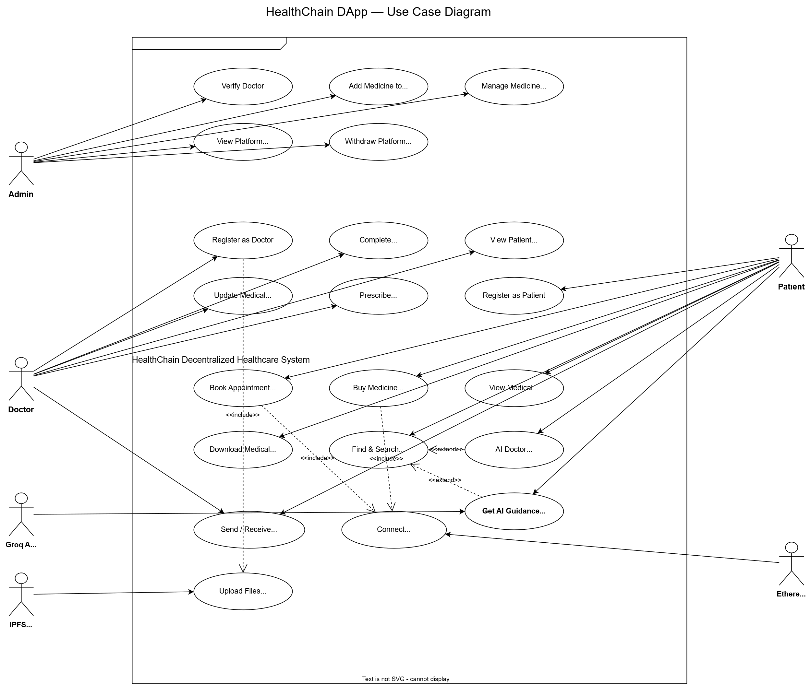
Figure 3.2 Usecase Daigram 1

3.3 Describe the Events Flow for Use Case

Use Case: Book Appointment
Primary Actor: Patient
Secondary Actors: MetaMask Wallet, Ethereum Blockchain, Smart Contract
Description: A verified patient books an appointment with a verified doctor by paying the required consultation fee in Ethereum (ETH).

Main Success Scenario (Flow of Events):
1. The Patient connects their MetaMask wallet and navigates to the "Find Doctors" or "Doctor Profile" page.
2. The Patient selects a verified Doctor and clicks the "Book Consultation" button.
3. The System displays the booking dialog, prompting for appointment date, time, and additional notes.
4. The Patient fills in the required details and clicks "Submit".
5. The System invokes the `bookAppointment()` smart contract function, passing the doctor's address, time, and note, along with the consultation fee in ETH.
6. MetaMask Wallet intercepts the transaction and prompts the Patient to confirm and sign the payment.
7. The Patient confirms the transaction in MetaMask.
8. The Ethereum Blockchain processes the transaction. The Smart Contract verifies the fee, deducts a 10% platform cut, transfers 90% to the doctor, and stores the appointment data.
9. The Smart Contract emits an `AppointmentBooked` event.
10. The System detects the successful transaction receipt and displays a success notification ("Appointment Booked!") to the Patient.

Alternative Flows:
- Insufficient Funds (Step 7): If the Patient does not have enough ETH to cover the consultation fee and gas, MetaMask rejects the transaction. The System displays an error message.
- Transaction Rejected (Step 7): If the Patient declines the signature prompt in MetaMask, the System catches the rejection and displays "Transaction cancelled by user."
- Doctor Not Verified (Step 5): If the selected doctor is not verified, the Smart Contract reverts the transaction with the error "Doctor is not verified." The booking fails.

4. CHAPTER NO 4: DESIGN

This chapter presents the detailed design of the Block chain based medical record management system using standard software engineering diagrams. Each diagram captures a specific design perspective — from the high-level system architecture down to the granular class-level interactions — ensuring a comprehensive blueprint that guided the implementation phase.

4.1 Architecture Diagram
The HealthChain platform follows a three-layer decentralized architecture.
- Layer 1 — Presentation (Frontend): A Next.js application that communicates with the blockchain exclusively through ethers.js v6 via the MetaMask-injected provider.
- Layer 2 — Business Logic (Smart Contract): A single Solidity contract (`Healthcare.sol`) deployed on the Ethereum network. It serves as the system's sole source of truth, handling all data structures, access control, and ETH transfers.
- Layer 3 — Decentralized Storage (IPFS): Pinata IPFS is used to store profile images and medical certificates securely off-chain, with their unique Content Identifiers (CIDs) stored on-chain.

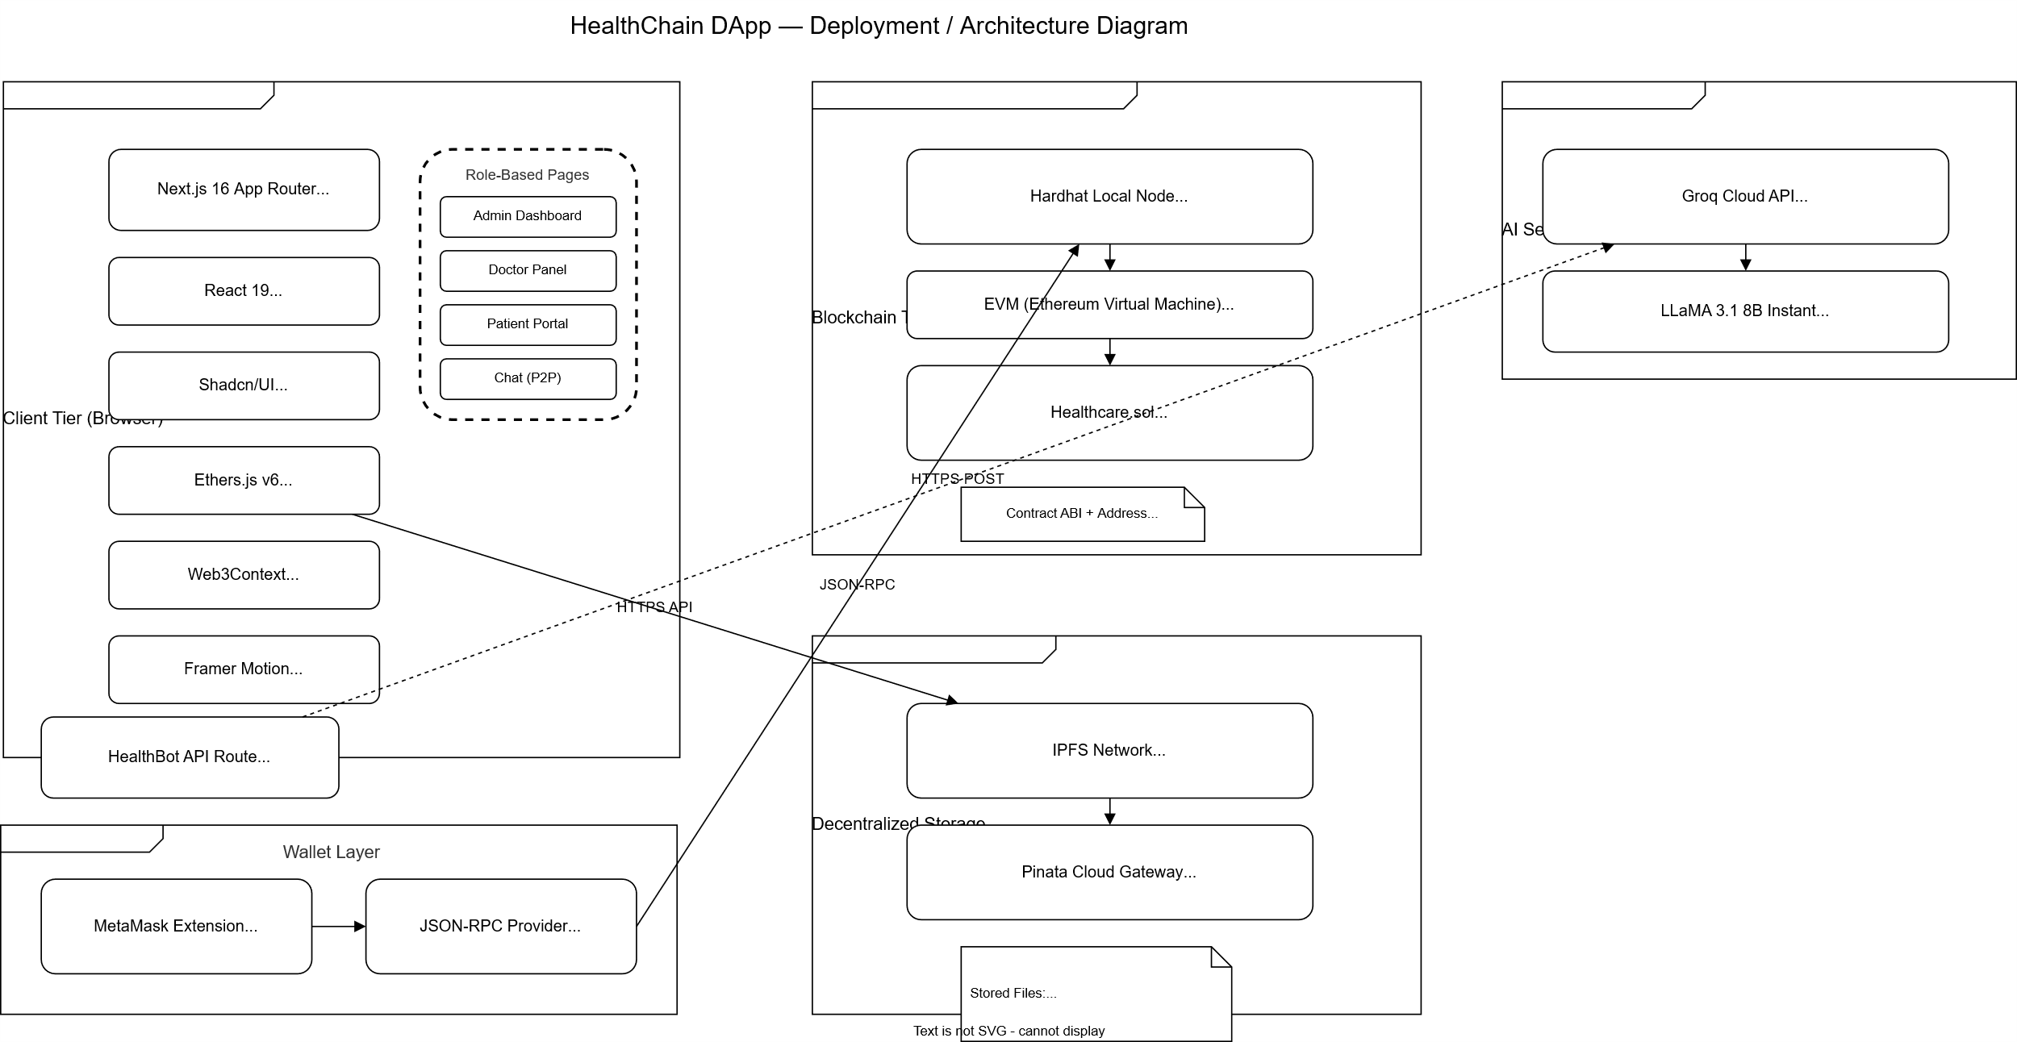
Figure 4.2 ERD Diagram 1

4.2 ERD with Data Dictionary
The Entity Relationship Diagram (ERD) models the logical data structures of the system.

Data Dictionary (Smart Contract Structs):
- Doctor: `wallet`, `name`, `specialization`, `experience`, `consultationFee`, `availableHours`, `profileImageURI`, `certificateURI`, `isVerified`, `isRegistered`
- Patient: `wallet`, `name`, `age`, `bloodGroup`, `allergies`, `currentMedications`, `profileImageURI`, `generalConsultant`, `isRegistered`
- Medicine: `id`, `name`, `manufacturer`, `category`, `dosage`, `price`, `stockQuantity`, `discount`, `sideEffects`, `imageURI`, `isActive`
- Appointment: `id`, `patient`, `doctor`, `time`, `note`, `isCompleted`
- MedicalRecord: `id`, `patient`, `doctor`, `diagnosis`, `medicalHistory`, `timestamp`
- Prescription: `id`, `patient`, `doctor`, `medicineId`, `dosageInstruction`, `quantity`, `timestamp`
- Message: `sender`, `receiver`, `content`, `timestamp`

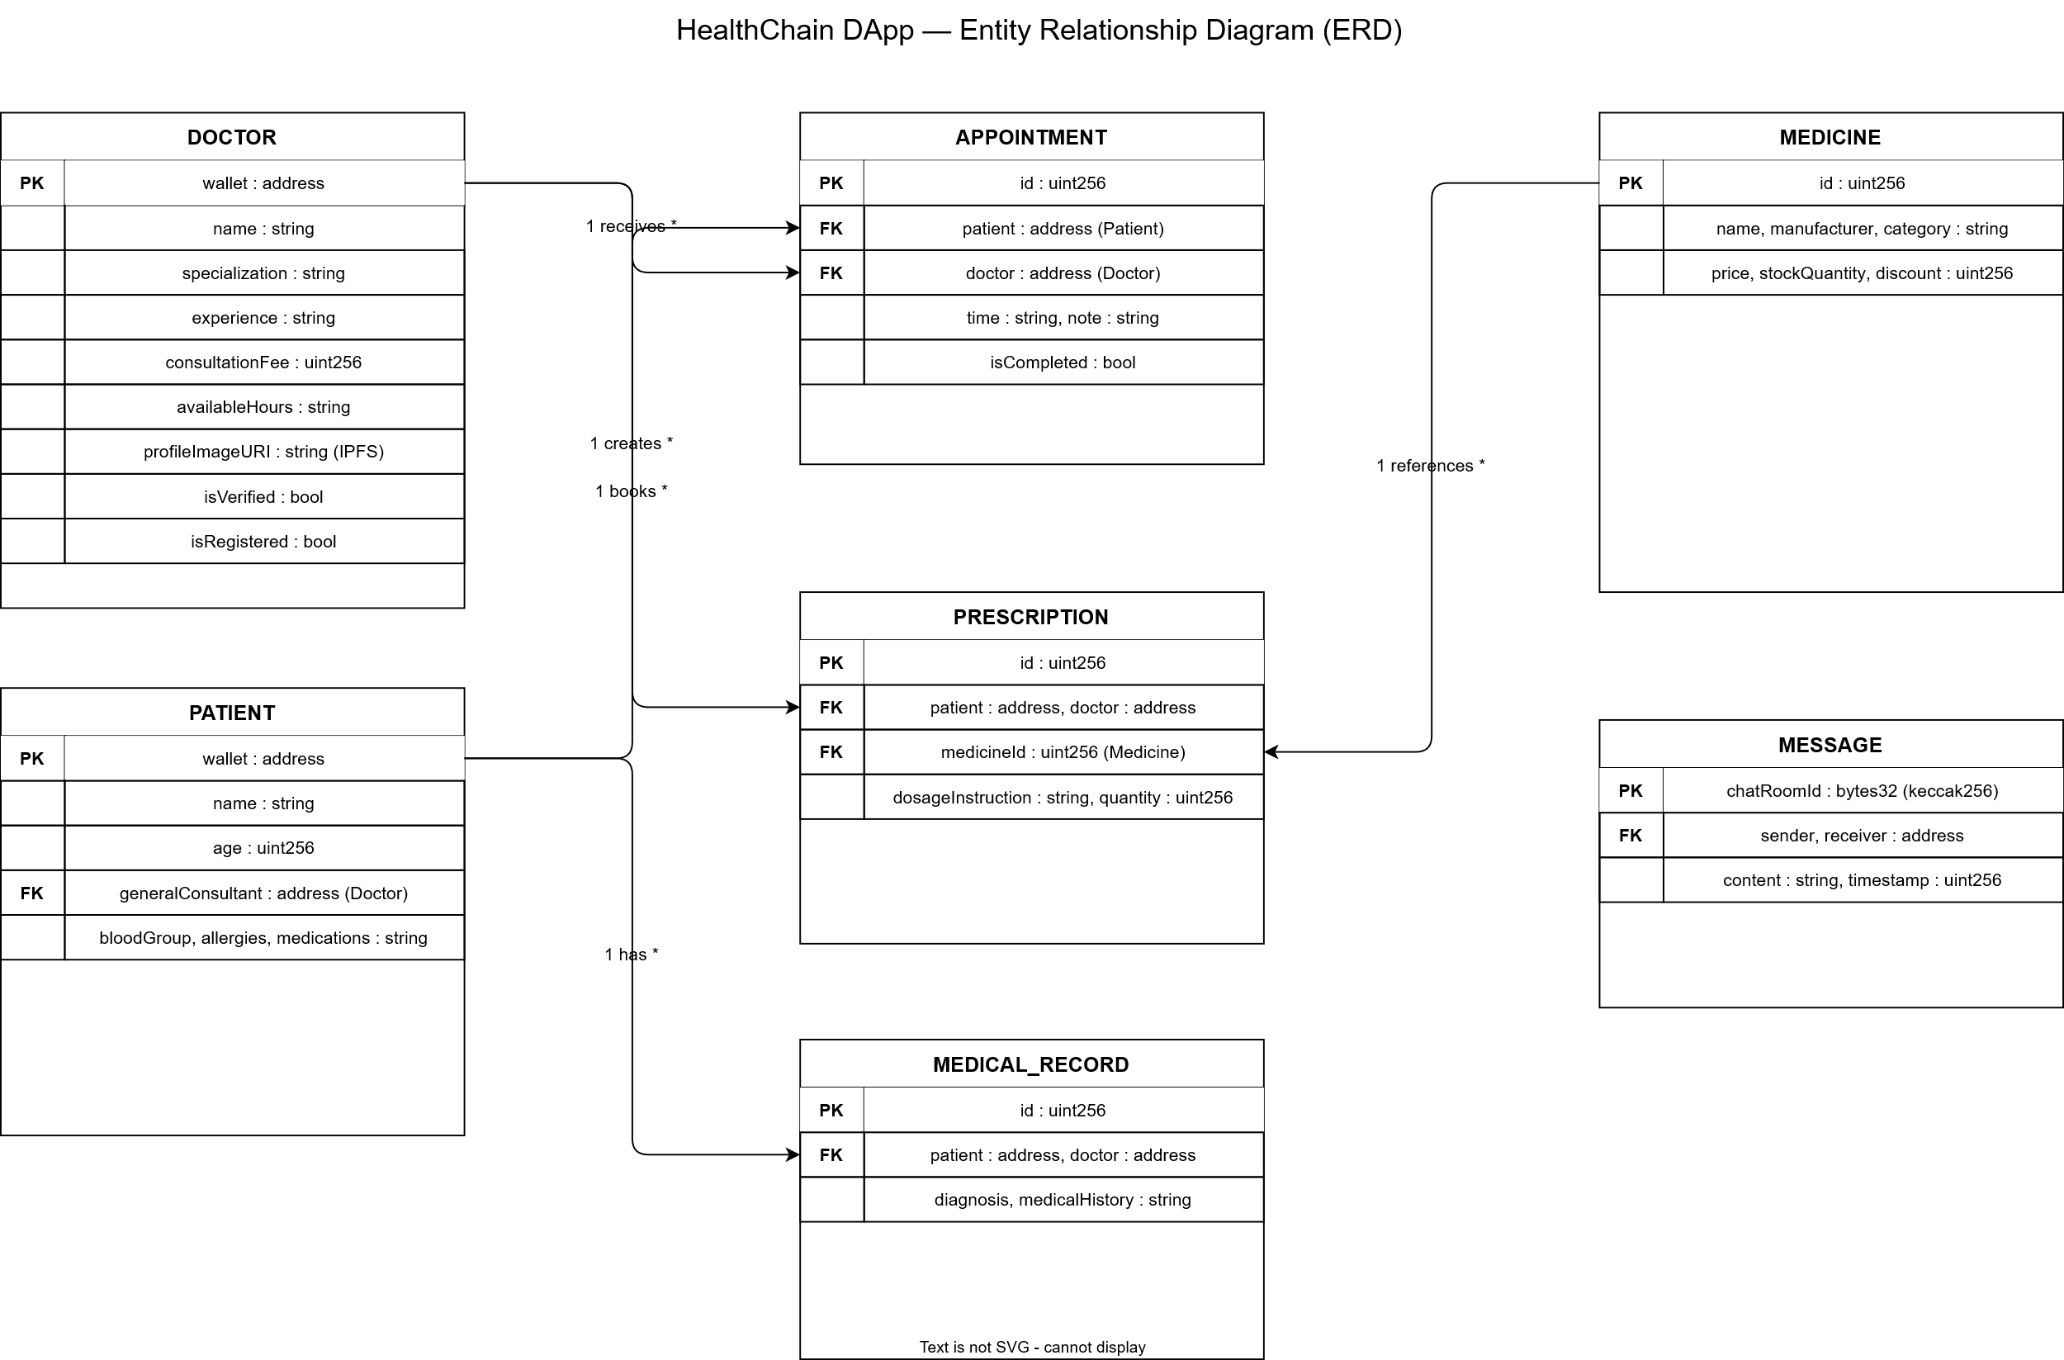
Figure 4.2 ERD Diagram 2

4.3 Data Flow Diagram (Level 0 and Level 1)

The Data Flow Diagrams map the flow of information between external entities (Admin, Doctor, Patient) and the system processes, data stores (Blockchain, IPFS).

4.3.1 Data Flow Diagram for Level 0

The Level 0 Context Diagram abstracts the entire HealthChain DApp as a single process.
- Admin inputs verification requests and medicine data; receives platform stats and revenue.
- Doctor inputs medical records and prescriptions; receives patient lists and appointments.
- Patient inputs registration data and ETH payments; receives medical history and doctor lists.

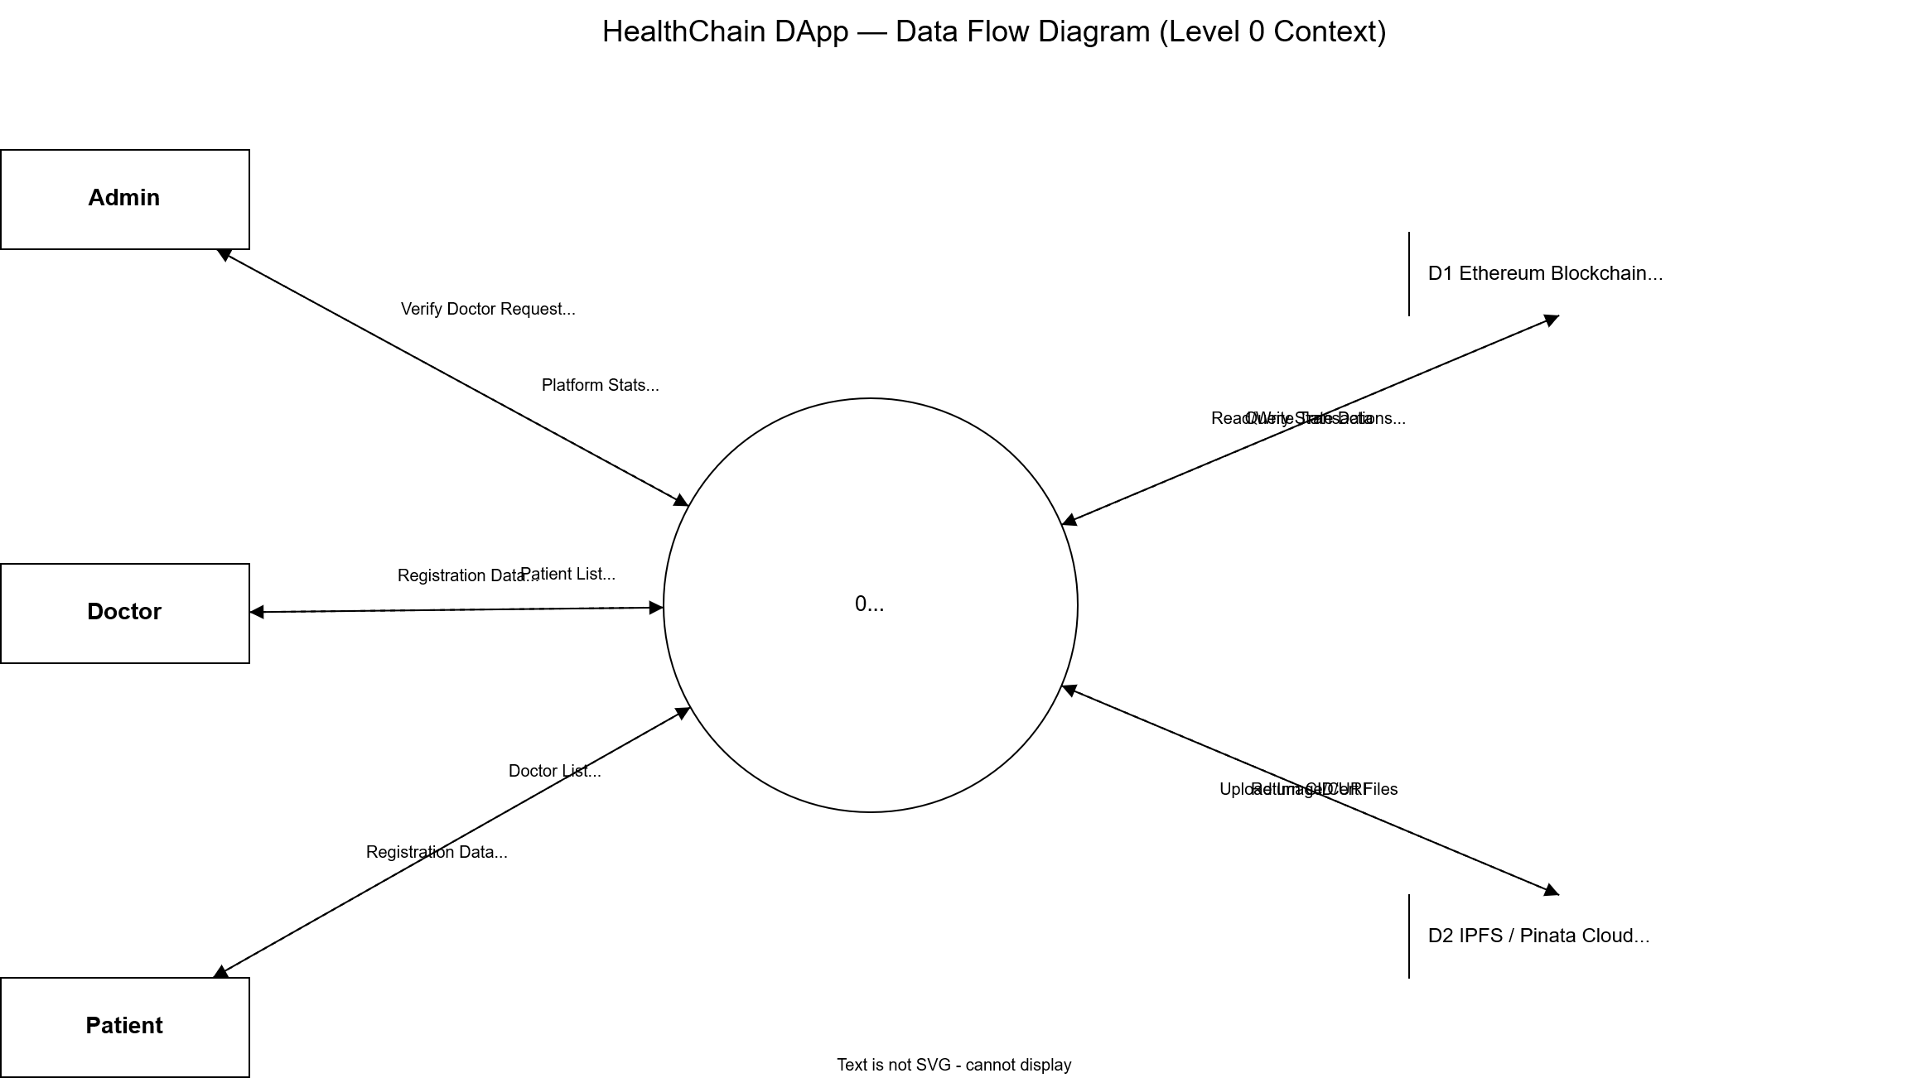
Figure 4.3.1 Data Flow Diagram 1

4.3.2 Data Flow Diagram for Level 1

The Level 1 DFD breaks down the central system into distinct sub-processes:
1. User Authentication & Registration: Handles wallet connections and IPFS uploads.
2. Consultation Management: Processes appointment bookings, ETH transfers, and record updates.
3. Pharmacy Management: Handles inventory, medicine purchases, and prescriptions.
4. Secure Messaging: Processes on-chain encrypted chat.

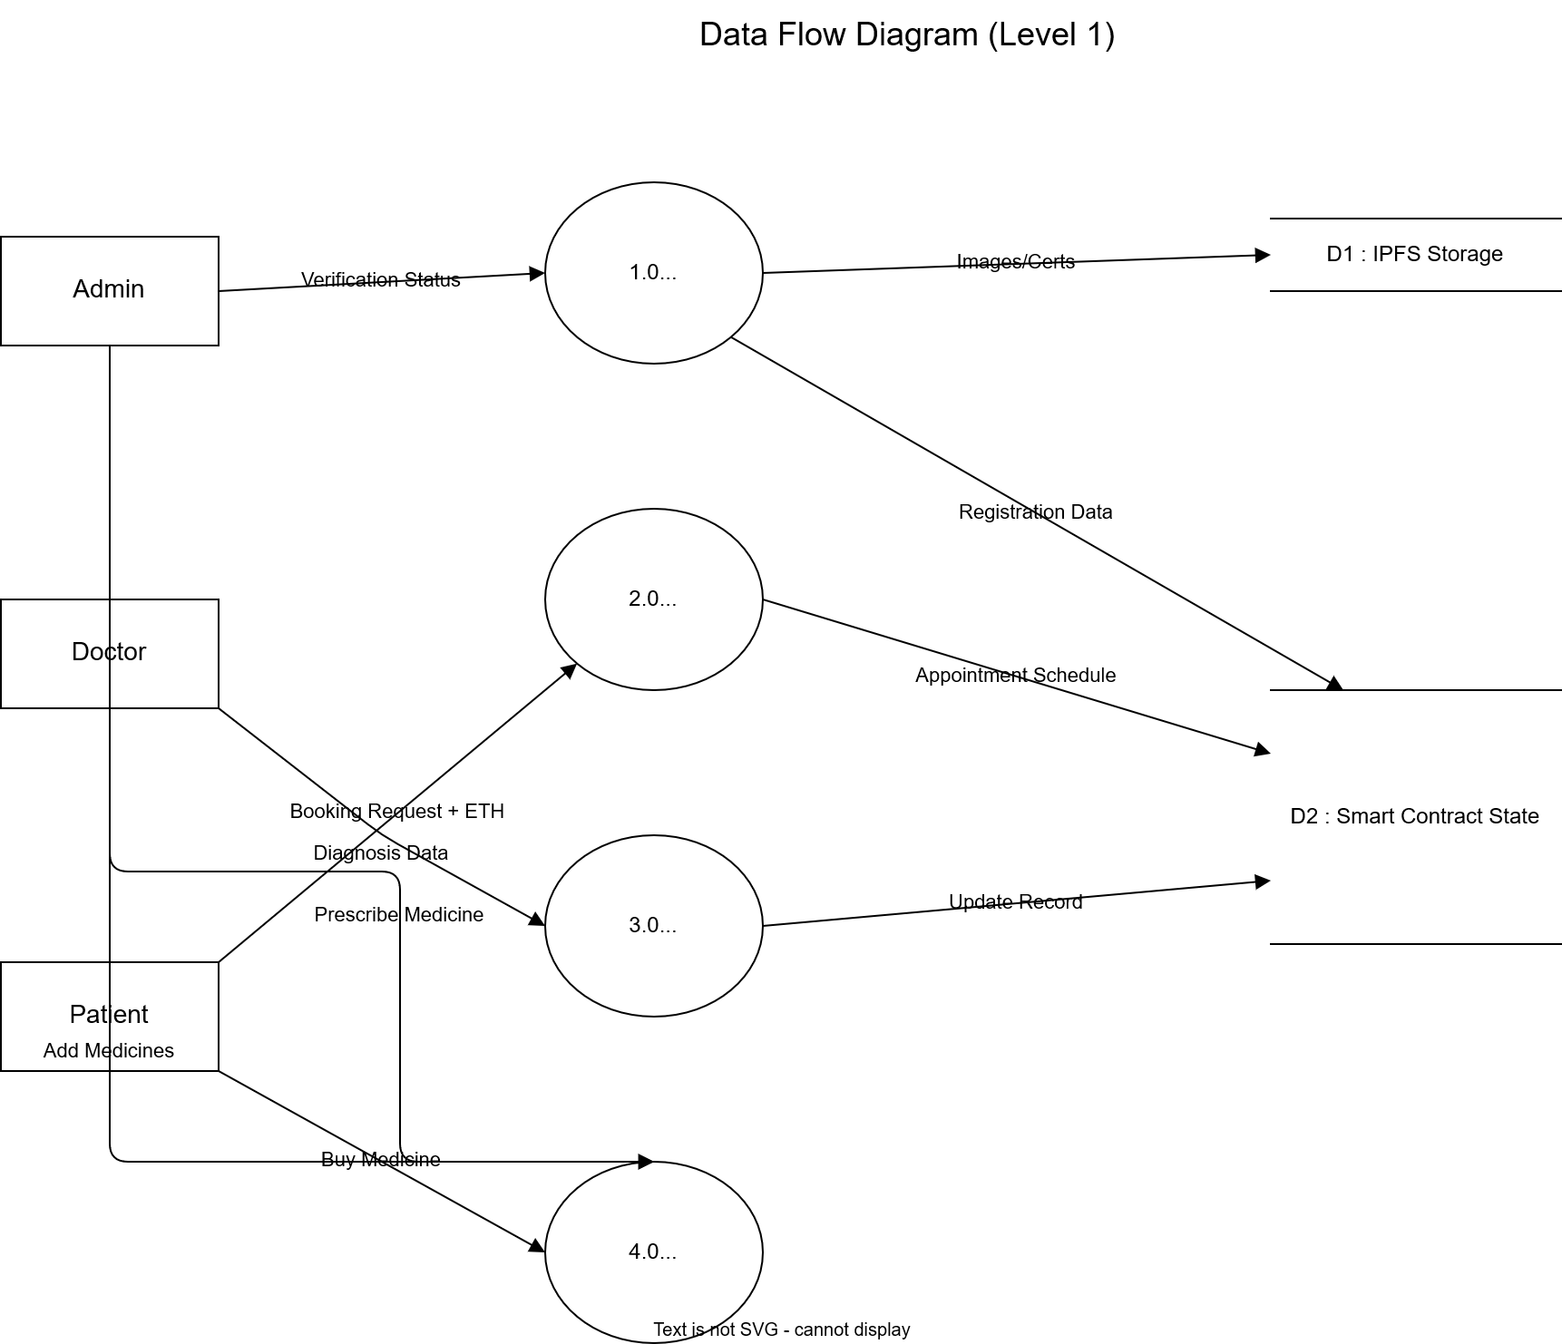
Figure 4.3.1 Data Flow Diagram 2

4.4 Class Diagram

In a traditional software system, a Class Diagram shows the blueprints of objects and how they interact. Since HealthChain is built entirely on the blockchain, our "classes" are actually Solidity structs (custom data types) stored inside the `Healthcare.sol` smart contract.
This section explains the core data models that run our system and how they connect with each other:
Doctor & Patient: These are the primary actors in the system. Instead of using traditional user IDs or emails, every Doctor and Patient is uniquely identified by their Ethereum wallet address.
Appointment: This acts as a bridge between the Doctor and the Patient. When a Patient books a session, an Appointment struct is created. It stores the patient's address, the doctor's address, the scheduled time, and the fee paid in ETH. It represents a one-to-many relationship: a Doctor handles many Appointments, and a Patient can book many Appointments over time.
Prescription & Medicine: After a consultation, a Doctor issues a Prescription. This struct links the treating Doctor, the receiving Patient, and the specific Medicine prescribed. The Medicine is a separate entity (managed by the Admin, like an inventory) that contains details like price and usage. This means one Medicine can appear in many Prescriptions.
Message: For the built-in communication system, the Message struct stores the sender, the receiver, the text content, and a timestamp. Because patients and doctors can chat with each other freely, this forms a many-to-many relationship between them.
Admin: The Admin is not a struct but a single, fixed wallet address stored at the contract level. The Admin has a one-to-many relationship with Doctors, as they are responsible for verifying all doctor registrations on the platform.
How They Are Stored (The Relationships):
Instead of using complex relational database tables with foreign keys, the smart contract uses Solidity `mapping`s (which work like dictionaries or hash tables). For example, `mapping(address => Doctor)` allows the system to instantly look up a Doctor's complete profile just by knowing their wallet address.

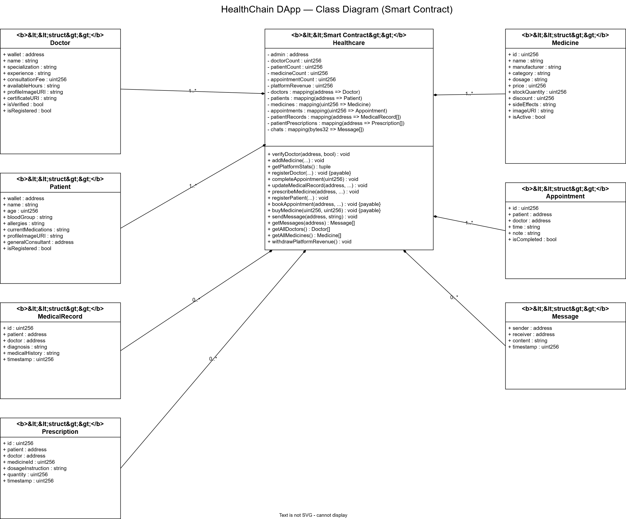
Figure 4.4 Class Diagram 1

4.5 Object Diagram

The Object Diagram presents a runtime snapshot of the HealthChain system, illustrating specific instantiated objects with representative data values. This diagram captures the state of the system at a point where one doctor has been registered and verified, one patient has been registered, and one appointment has been booked.
Object Name | Class | Attribute | Value
doctor1 | Doctor | walletAddress | 0xABCD...1234
 |  | Name | Dr. Ahmed
 |  | specialization | Cardiology
 |  | isVerified | True
patient1 | Patient | walletAddress | 0x1234...ABCD
 |  | Name | Sara Khan
 |  | bloodGroup | O+
 |  | assignedDoctor | 0xABCD...1234
appointment1 | Appointment | appointmentId | 1
 |  | patientAddress | 0x1234...ABCD
 |  | doctorAddress | 0xABCD...1234
 |  | Fee | 0.05 ETH
 |  | isCompleted | False
4 Class Diagram ex 1

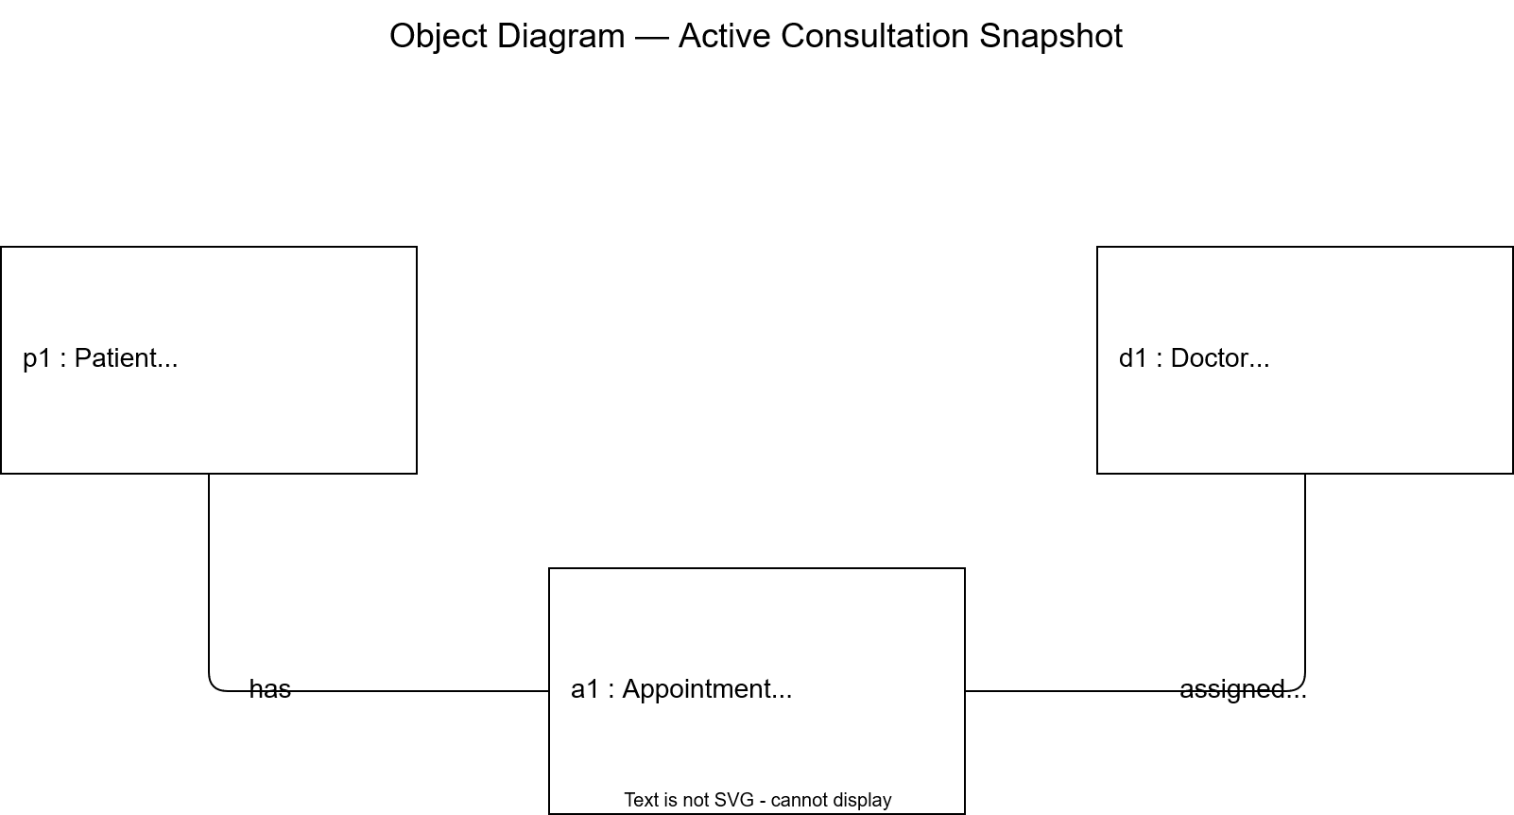
Figure 4.5 Object Diagram 1

4.6 Sequence Diagram
The Sequence Diagram illustrates the time-ordered interaction between system participants for the appointment booking process, which represents the most complex transactional flow in the HealthChain system.

Step | From | To | Message / Action
1 | Patient Browser | Next.js Frontend | User clicks “Book Appointment” button
2 | Next.js Frontend | ethers.js | Prepare bookAppointment() transaction with ETH value
3 | ethers.js | MetaMask | Request transaction signature from user
4 | MetaMask | Patient | Display confirmation dialog: “Confirm transaction (0.05 ETH)?”
5 | Patient | MetaMask | Approve transaction
6 | MetaMask | Hardhat Node | Submit signed transaction to blockchain network
7 | Hardhat Node | Healthcare.sol | Execute bookAppointment() smart contract function
8 | Healthcare.sol | Healthcare.sol | Validate payment amount and create Appointment struct
9 | Healthcare.sol | Doctor Wallet | Transfer doctor fee in ETH
10 | Healthcare.sol | Event Logs | Emit AppointmentBooked event
11 | Hardhat Node | ethers.js | Return transaction receipt
12 | Next.js Frontend | Patient Browser | Display success notification and update UI
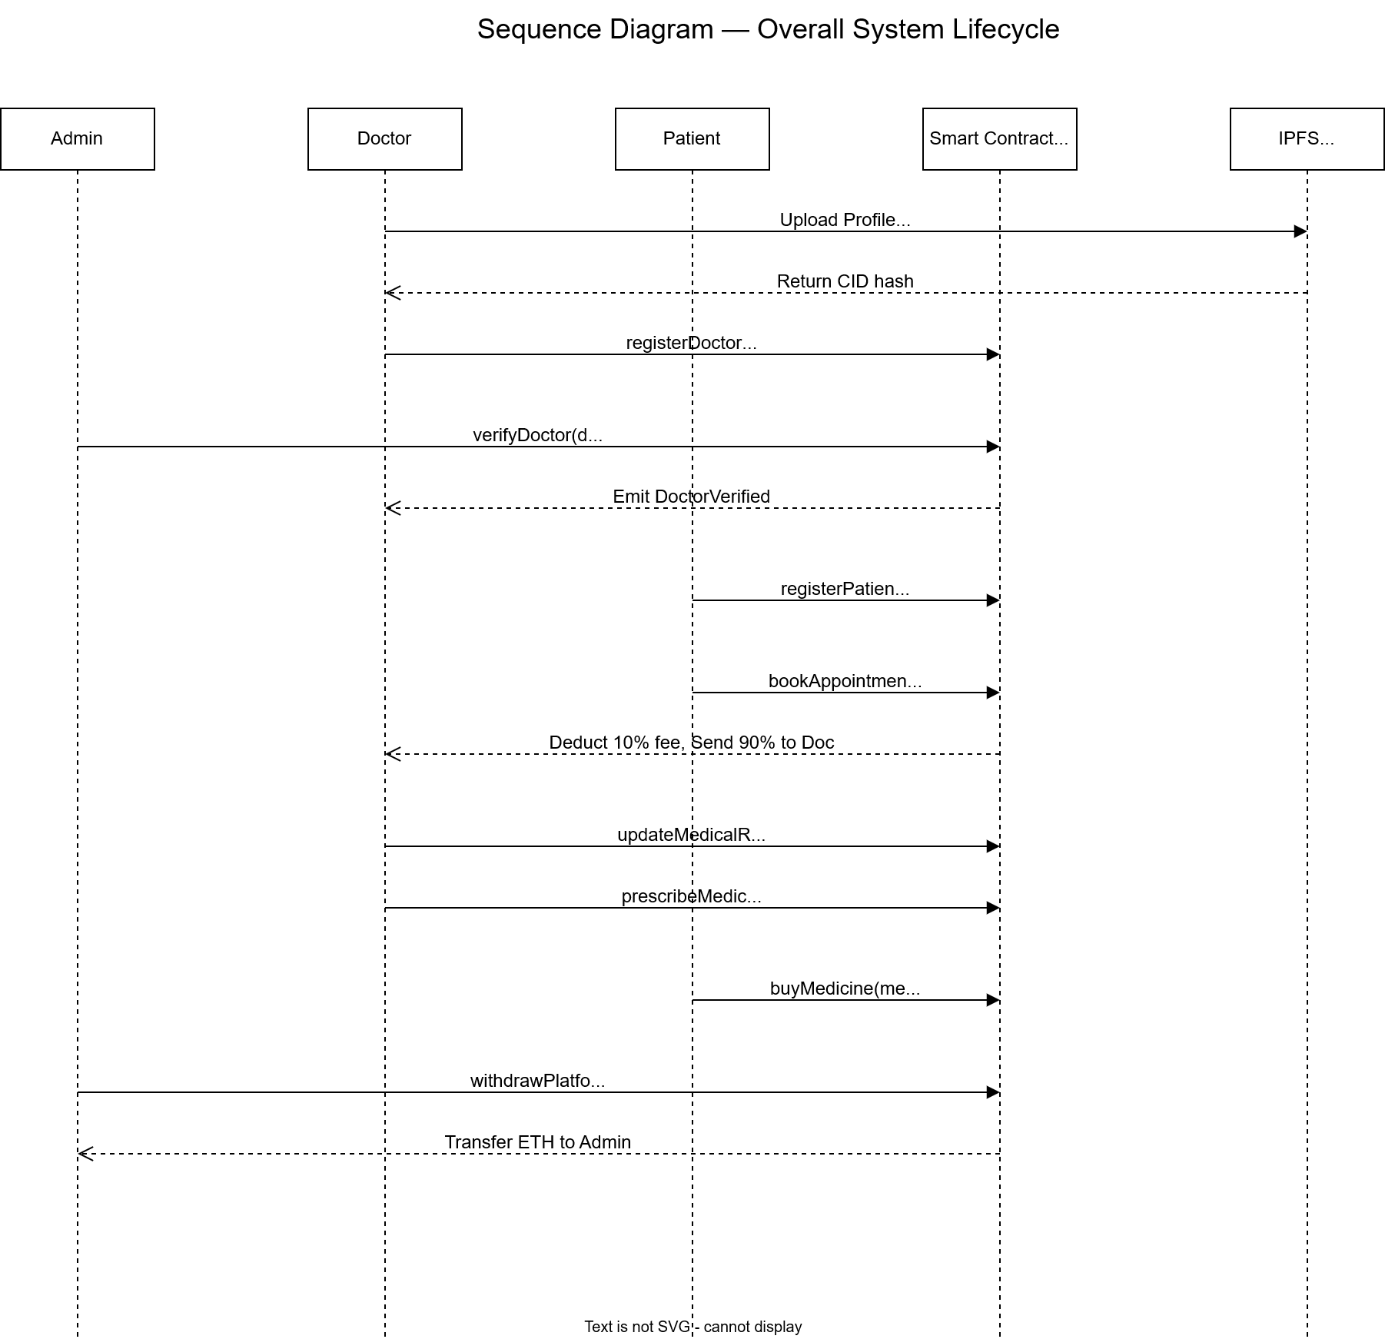
Figure 4 Sequence Diagram 1

4.7 Activity Diagram
Activity Diagrams map the procedural flow of control within a process. For instance, the Patient Registration Activity starts by checking for MetaMask installation. It then evaluates if the selected consultant is verified. The system uploads images to IPFS, executes the registerPatient() function on-chain, and concludes by emitting success events.
The Collaboration (or Communication) Diagram emphasizes the structural relationships between objects interacting to perform a behavior. It showcases how the Next.js Frontend collaborates with the Ethers.js provider, which in turn communicates with the MetaMask Wallet to sign transactions before interacting with the deployed Hardhat Blockchain node and IPFS gateway.

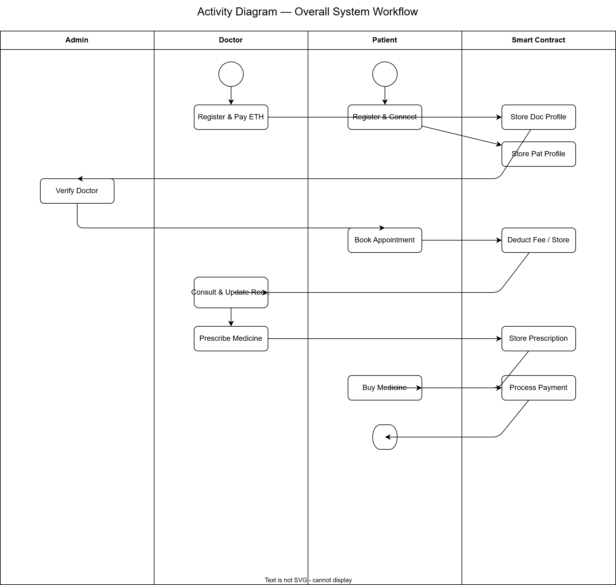
Figure 4.7 Activity Diagram 1

4.8 Collaboration Diagram

The Collaboration (or Communication) Diagram emphasizes the structural relationships between objects interacting to perform a behavior. It showcases how the Next.js Frontend collaborates with the Ethers.js provider, which in turn communicates with the MetaMask Wallet to sign transactions before interacting with the deployed Hardhat Blockchain node and IPFS gateway.

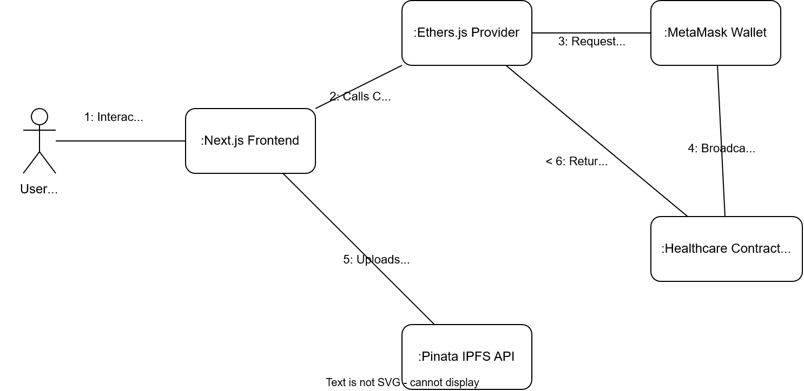

Figure Collaboration Diagram 1

CHAPTER NO 5: IMPLEMENTATION

5.1 Component Diagram
The Component Diagram provides a high-level view of the system's modular architecture. The HealthChain DApp is divided into the Frontend Components (Next.js UI, Ethers.js API), the Blockchain Components (Healthcare.sol Smart Contract), and the Storage Components (Pinata IPFS). These components interface with each other via defined protocols like Web3 RPC and HTTPS.
The Deployment Diagram illustrates the physical hardware and software execution environments. The user's device runs a Web Browser with the MetaMask extension. The Next.js frontend is served via a Web Server (e.g., Vercel or localhost). The Smart Contract resides on the Ethereum Blockchain Nodes, while the IPFS network handles decentralized file storage.
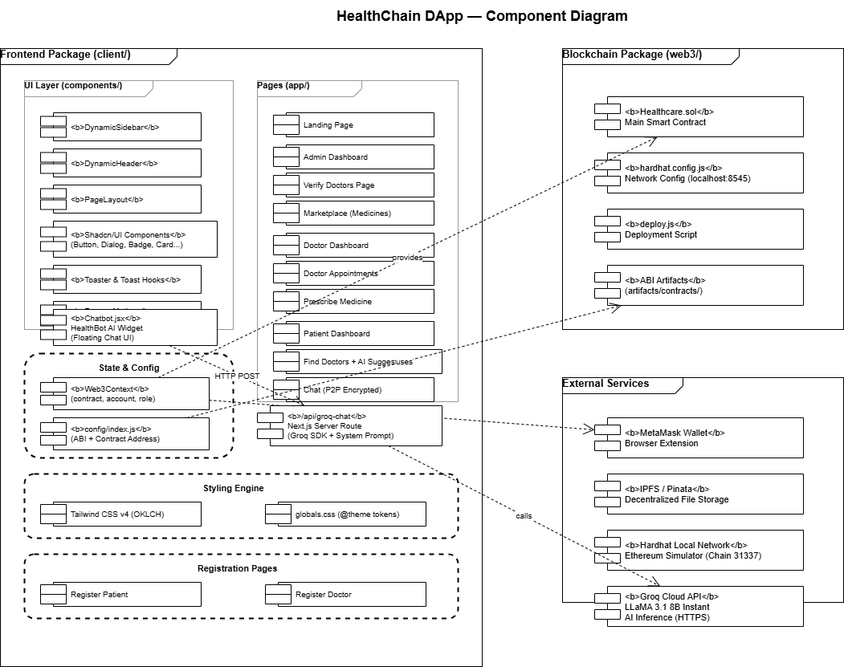
Figure 5 Component Diagram 1

5.2 Deployment Diagram
The Deployment Diagram illustrates the physical hardware and software execution environments. The user's device runs a Web Browser with the MetaMask extension. The Next.js frontend is served via a Web Server (e.g., Vercel or localhost). The Smart Contract resides on the Ethereum Blockchain Nodes, while the IPFS network handles decentralized file storage.

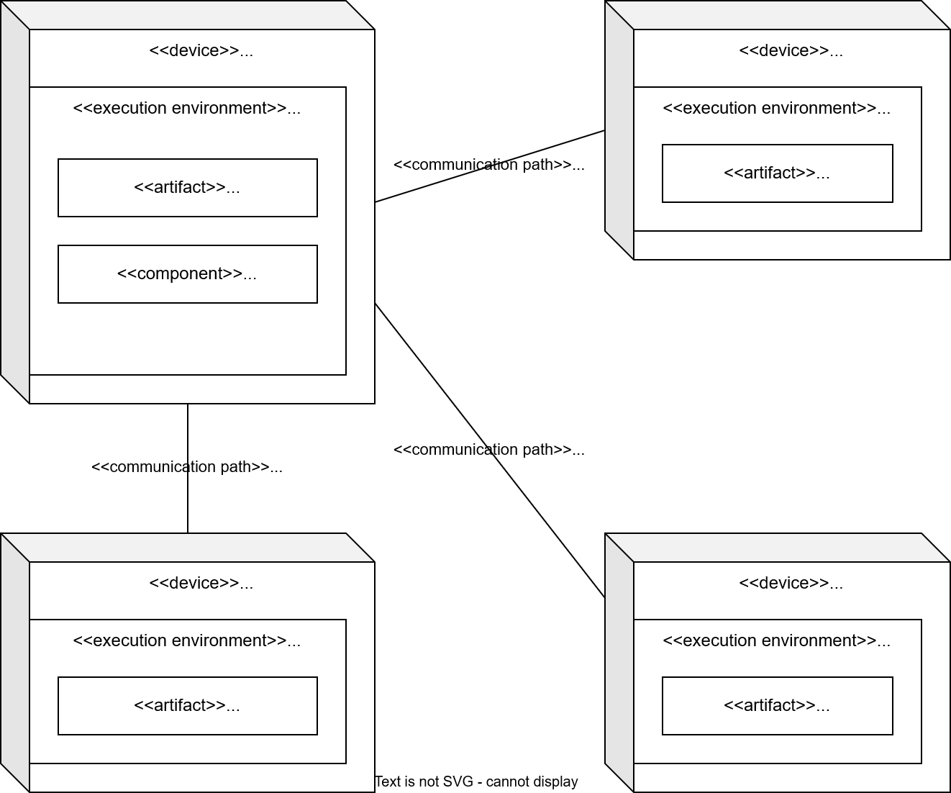
Figure 5.2 Deployment Diagram 1

HealthChain employs a fundamentally different approach compared to traditional databases. Rather than a standard tier architecture, it utilizes a decentralized architecture where the Blockchain acts as the persistent state layer.

5.3 Database Architecture (1- Tier, 2-Tier, 3- Tier Architecture)
HealthChain employs a fundamentally different approach compared to traditional databases. Rather than a standard tier architecture, it utilizes a decentralized architecture where the Blockchain acts as the persistent state layer.

5.3.1 1-Tier Architecture
In a traditional 1-tier setup, the database and application run on the same local machine. For HealthChain, during local development using Hardhat, the system acts somewhat analogously, where the Hardhat node stores the blockchain state locally on the developer's machine.

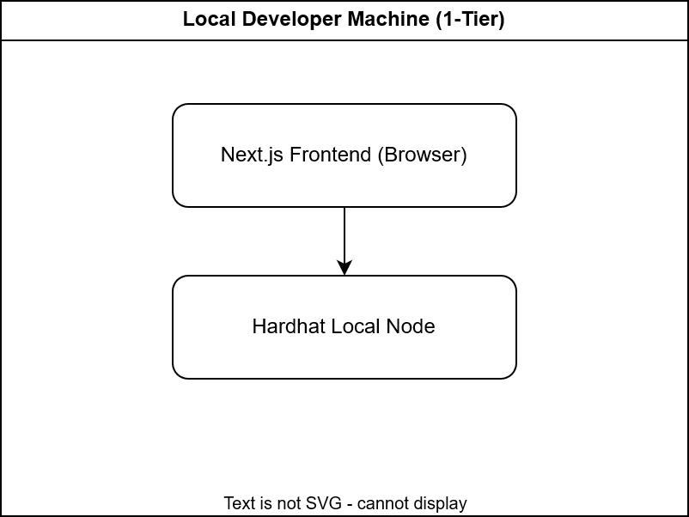

5.3.2 2-Tier Architecture
In a 2-tier client-server model, the client directly communicates with the database server. In HealthChain, the Web3 Frontend (Client) interacts directly with the Ethereum Blockchain (Server/State) using Ethers.js and MetaMask, effectively mirroring a 2-tier architecture where the smart contract replaces the SQL database.

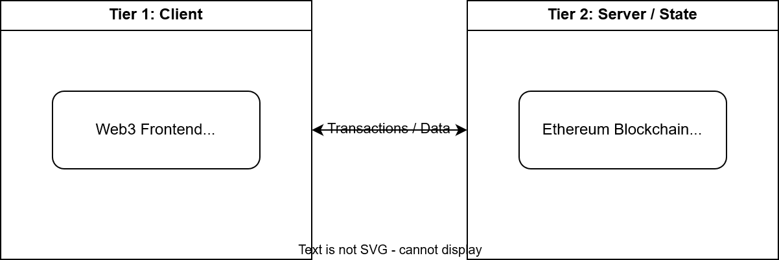

5.3.3 3-Tier Architecture

While not a traditional 3-tier system, HealthChain's integration of IPFS introduces a third dimension. The Frontend (Tier 1) communicates with the Smart Contract for logical state (Tier 2) and with IPFS via Pinata for large file storage (Tier 3), creating a decentralized multi-tier architecture.

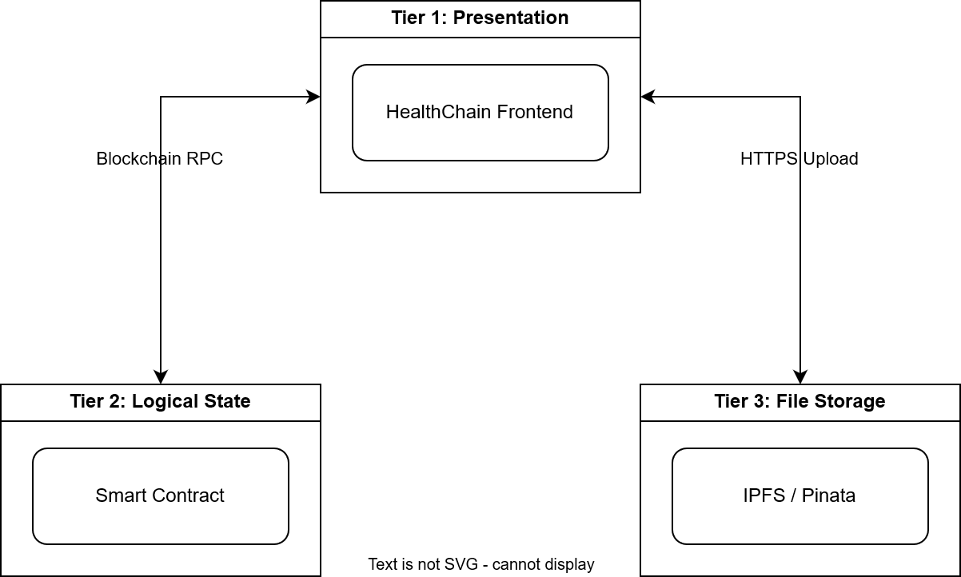

CHAPTER NO 6: TESTING (SOFTWARE QUALITY ATTRIBUTES)

The test case specification details the testing strategy to ensure all functionalities meet the software requirements. Testing in HealthChain focuses on smart contract validation, transaction integrity, and frontend-blockchain integration, utilizing both black-box and white-box methodologies.

6.1 Test Case Specification

Software testing for the HealthChain system is conducted at two levels: Black Box testing (functional testing from the user's perspective, without knowledge of internal implementation) and White Box testing (structural testing examining internal code paths). The system under test is the Healthcare.sol smart contract and the Next.js frontend application.

The primary testing objectives are:
1. To verify that each functional requirement defined in Chapter 2 is correctly implemented.
2. To ensure that unauthorized access attempts are correctly rejected by the smart contract.
3. To confirm that financial transactions distribute ETH correctly.
4. To validate that the system handles boundary and edge cases without failure.

All test cases are documented with: Test Case ID, Test Objective, Input, Expected Output, and Actual Output fields.

6.2 Black Box Test Cases
Black box testing focuses on verifying the software's input-output behavior without considering its internal logic. In HealthChain, this involves testing UI components, form submissions, and smart contract function calls with various inputs to ensure expected outputs like error messages or successful transactions.
BVA tests the system's behavior at the edge limits of input ranges. For example, testing the consultation fee payment by sending exactly the required ETH (lower boundary), slightly less ETH (invalid boundary), and more ETH (upper boundary) to ensure correct refund logic.

6.2.1 Boundary Value Analysis (BVA)
BVA tests the system's behavior at the edge limits of input ranges. For example, testing the consultation fee payment by sending exactly the required ETH (lower boundary), slightly less ETH (invalid boundary), and more ETH (upper boundary) to ensure correct refund logic.
ECP divides inputs into valid and invalid classes. For instance, in doctor registration, valid classes include complete forms with IPFS images and the correct registration fee. Invalid classes include missing fields, invalid wallet addresses, or insufficient fees.
TC ID | Test Case | Input | Expected Output | Actual Output
BVA-01 | Book appointment with exact fee | ETH value = exact consultation fee | Transaction succeeds; appointment created | Pass
BVA-02 | Book appointment with fee minus 1 wei | ETH value = (fee - 1 wei) | Transaction reverted: "Insufficient payment" | Pass
BVA-03 | Book appointment with fee plus 1 wei | ETH value = (fee + 1 wei) | Transaction reverted: "Incorrect payment amount" | Pass
BVA-04 | Register doctor with age = 0 | age = 0 | Registration rejected: "Invalid age" | Pass
BVA-05 | Register doctor with age = 100 | age = 100 | Registration accepted | Pass
BVA-06 | Register doctor with age = 101 | age = 101 | Registration rejected: "Age out of range" | Pass
BVA-07 | Buy medicine with exact price | ETH = medicine.price | Purchase succeeds; sale recorded | Pass
BVA-08 | Buy medicine with price minus 1 wei | ETH = (price - 1 wei) | Transaction reverted: "Incorrect payment" | Pass
6.2.1 Boundary Value 1

6.2.2 Equivalence Class Partitioning
ECP divides inputs into valid and invalid classes. For instance, in doctor registration, valid classes include complete forms with IPFS images and the correct registration fee. Invalid classes include missing fields, invalid wallet addresses, or insufficient fees.
State transition testing verifies the system's behavior as entities change state. For example, a Doctor entity transitions from 'Unverified' to 'Verified' when the Admin calls verifyDoctor(), and an Appointment transitions from 'Pending' to 'Completed' when marked by the doctor.
TC ID | Partition | Test Input | Expected Output | Actual Output
ECP-01 | Valid: Registered patient booking appointment | Registered patient address | Appointment booked successfully | Pass
ECP-02 | Invalid: Unregistered address booking appointment | Unregistered wallet address | Transaction reverted: "Not a registered patient" | Pass
ECP-03 | Valid: Verified doctor submitting medical record | Verified doctor address | Record created and stored on-chain | Pass
ECP-04 | Invalid: Unverified doctor submitting medical record | Unverified doctor address | Transaction reverted: "Doctor not verified" | Pass
ECP-05 | Valid: Admin calling withdrawRevenue() | Deployer address | ETH transferred to admin wallet | Pass
ECP-06 | Invalid: Non-admin calling withdrawRevenue() | Non-deployer address | Transaction reverted: "Not authorized" | Pass
ECP-07 | Valid: Patient purchasing active medicine | Active medicine ID | Purchase recorded; ETH transferred | Pass
ECP-08 | Invalid: Patient purchasing inactive medicine | Inactive medicine ID | Transaction reverted: "Medicine not available" | Pass
6.2.2 Equivalence Class Partitioning 1

6.2.3 State Transition Testing
State transition testing verifies the system's behavior as entities change state. For example, a Doctor entity transitions from 'Unverified' to 'Verified' when the Admin calls verifyDoctor(), and an Appointment transitions from 'Pending' to 'Completed' when marked by the doctor.
Decision tables evaluate complex business logic. In HealthChain, a decision table for medicine purchase checks combinations of factors: Does the patient have enough ETH? Is the medicine stock greater than zero? The transaction succeeds only if all required conditions are true.
TC ID | From State | Transition | To State | Expected Behavior | Actual Output
STT-01 | Unregistered | registerDoctor() called with valid data | Registered (Pending) | isRegistered = true, isVerified = false | Pass
STT-02 | Registered (Pending) | verifyDoctor() called by Admin | Verified | isVerified = true; doctor can accept appointments | Pass
STT-03 | Registered (Pending) | rejectDoctor() called by Admin | Unregistered | Doctor struct removed; fee refunded | Pass
STT-04 | Verified | Doctor attempts to re-register | Verified (unchanged) | Transaction reverted: "Already registered" | Pass
STT-05 | Unregistered | Appointment booking attempted | Unregistered (unchanged) | Transaction reverted: "Not a patient" | Pass
6.2.3 State Transition 1
Appointment Lifecycle States: Pending, Completed.
TC ID | From State | Transition | To State | Expected Behavior | Actual Output
STT-06 | Pending | completeAppointment() by assigned doctor | Completed | isCompleted = true; timestamp recorded | Pass
STT-07 | Pending | completeAppointment() by different doctor | Pending (unchanged) | Transaction reverted: "Not your appointment" | Pass
STT-08 | Completed | completeAppointment() called again | Completed (unchanged) | Transaction reverted: "Already completed" | Pass
6.2.3 Appointment Lifecycle 1

6.2.4 Decision Table Testing
Decision tables evaluate complex business logic. In HealthChain, a decision table for medicine purchase checks combinations of factors: Does the patient have enough ETH? Is the medicine stock greater than zero? The transaction succeeds only if all required conditions are true.
Graph-based testing models the application flow. It involves tracing the transaction paths, such as the flow from the user signing a MetaMask transaction to the smart contract executing the logic and emitting the final confirmation event back to the UI.

6.2.5 Graph Base Testing
Graph-based testing models the application flow. It involves tracing the transaction paths, such as the flow from the user signing a MetaMask transaction to the smart contract executing the logic and emitting the final confirmation event back to the UI.White box testing examines the internal structure and logic of the smart contract code. Using tools like Hardhat and Chai, unit tests verify that the Solidity code executes correctly.

6.3 White Box Testing
White box testing examines the internal structure and logic of the smart contract code. Using tools like Hardhat and Chai, unit tests verify that the Solidity code executes correctly.
Statement coverage ensures every line of code in the smart contract is executed at least once during testing. This includes all require() checks, variable assignments, and mathematical calculations within the Healthcare.sol contract.

6.3.1 Statement Coverage
Statement coverage ensures every line of code in the smart contract is executed at least once during testing. This includes all require() checks, variable assignments, and mathematical calculations within the Healthcare.sol contract.
Branch coverage tests all possible execution paths of conditional statements. For example, testing the `if` conditions in the message room hashing function or the automatic refund logic where excess ETH is sent back to the user.

6.3.2 Branch Coverage
Branch coverage tests all possible execution paths of conditional statements. For example, testing the `if` conditions in the message room hashing function or the automatic refund logic where excess ETH is sent back to the user.
Path coverage involves testing all possible independent paths through a function from entry to exit. This ensures complex functions like `bookAppointment()` are fully validated for all variations of inputs and state conditions.

6.3.3 Path Coverage
Path coverage involves testing all possible independent paths through a function from entry to exit. This ensures complex functions like `bookAppointment()` are fully validated for all variations of inputs and state conditions.

CHAPTER NO 7: TOOLS AND TECHNOLOGIES
HealthChain is built using Solidity (v0.8.20) for the smart contract, which handles all on-chain logic. The frontend is developed in JavaScript/TypeScript using the React-based Next.js framework (v14), with Tailwind CSS for styling.

7.1 Programming Languages
The HealthChain system is developed using three primary programming languages, each serving a distinct architectural role:
Solidity (v0.8.20)
Solidity is a statically typed, contract-oriented programming language specifically designed for the Ethereum Virtual Machine. It was selected as the smart contract language because it is the dominant and most mature language for EVM-based development, with comprehensive documentation, active tooling support, and built-in constructs for common blockchain patterns such as access modifiers, event emission, and value transfer. The ^0.8.20 version pragma ensures access to the overflow protection introduced in Solidity 0.8.0, which eliminates a common class of integer overflow vulnerabilities that previously required the OpenZeppelin SafeMath library.
JavaScript / TypeScript
JavaScript is the primary language for the Next.js frontend application. All React components, custom hooks (including the useWeb3 hook for blockchain interaction), API routes, and configuration files are written in JavaScript (ES2022+). JavaScript was chosen because of its seamless integration with the React ecosystem, the Next.js framework, and the ethers.js library. The ethers.js v6 library, which provides the ABI encoding and JSON-RPC communication required to interact with the Ethereum smart contract from the browser, is a JavaScript library.
CSS (via Tailwind CSS v4)
Cascading Style Sheets with Tailwind CSS v4 utility classes are used for all visual styling. Tailwind v4 introduces an OKLCH color space for perceptually uniform color management and defines design tokens through the @theme CSS directive rather than a JavaScript configuration file. This approach reduces the build toolchain dependency and improves runtime performance.
Language / Framework | Version | Role
Solidity | ^0.8.20 | Smart contract logic and on-chain data storage
JavaScript | ES2022+ | Frontend components, API routes, and Web3 integration
CSS / Tailwind CSS | v4 | Application styling and responsive user interface layout
7.1 Language Framerworks 1

7.2 Operating Environment
The HealthChain system operates within the following software and hardware environment:

Development Environment:

Component | Technology | Version
Smart Contract Framework | Hardhat | ^2.28.6
Frontend Framework | Next.js | ^16.2.4
Blockchain Library | ethers.js | ^6.16.0
UI Animation | Framer Motion | ^12.34.3
UI Components | Radix UI / Shadcn | Latest
Form Validation | React Hook Form + Zod | Latest
File Storage SDK | Pinata (REST API) | v1
AI SDK | Groq SDK | ^0.x
AI Model | LLaMA 3.1 8B Instant | Via Groq Cloud
Icons | Lucide React | ^1.8.0
Package Manager | Npm | ^10.x
Node.js Runtime | Node.js | ^20.x
7.2 Development Environment 1
Operating System: Microsoft Windows 10/11 (64-bit) or Ubuntu 20.04 LTS or later. The system is operating-system agnostic at the application level, as all runtime dependencies (Node.js, npm, Hardhat) are cross-platform.
Browser Requirement: Google Chrome (version 100+) or any Chromium-based browser (Microsoft Edge, Brave) with the MetaMask extension installed and configured. Firefox with MetaMask is also supported.
Network Requirements: A stable internet connection is required for IPFS file uploads via Pinata and for HealthBot AI inference via the Groq Cloud API. The core blockchain functionality (smart contract interaction) operates entirely on localhost and does not require internet access.
Minimum Hardware Requirements:
Component | Minimum Specification
Processor | Intel Core i5 (8th generation) or equivalent
RAM | 4 GB (8 GB recommended for simultaneous Hardhat + Next.js)
Storage | 10 GB available disk space for Node.js dependencies and blockchain data
Display | 1280 × 720 resolution minimum
Network | Broadband internet connection (for IPFS and Groq API calls)
7.2 Minimum Hardware Requirements 1

APPENDIX A: USER DOCUMENTATION
A.1 System Requirements

Before using the HealthChain platform, the following prerequisites must be satisfied:

1. A personal computer running Windows, macOS, or Linux with a modern web browser installed.
2. The MetaMask browser extension installed (available at metamask.io).
3. MetaMask configured with at least one Ethereum account.
4. The HealthChain local development server running on localhost:3000.
5. The Hardhat blockchain node running on localhost:8545.

A.2 Configuring MetaMask for HealthChain

1. Open MetaMask and click the network selector at the top of the extension.
2. Click "Add Network" and then "Add a network manually."
3. Enter the following details:
- Network Name: Hardhat Local
- New RPC URL: http://localhost:8545
- Chain ID: 31337
- Currency Symbol: ETH
4. Click Save. MetaMask will switch to the Hardhat Local network.
5. Import a test account: In Hardhat terminal output, copy a private key from the listed test accounts. In MetaMask, click Account menu > Import Account > paste the private key.

A.3 User Guide by Role

For New Users (Unregistered):
1. Visit http://localhost:3000 in your browser.
2. Click "Connect Wallet" at the top of the page.
3. Approve the connection in MetaMask.
4. The system will detect that your address is unregistered and present a registration selection screen.
5. Select "Register as Patient" or "Register as Doctor" as appropriate.

For Patients:
1. After registration, you will be directed to the Patient Portal.
2. Use "Find Doctors" to browse verified doctors and book appointments.
3. Your medical history is accessible under "Medical Records."
4. Prescriptions issued by your doctor are visible under "Prescriptions."
5. The Medicine Marketplace lists available medications for purchase.
6. Use the Chat feature to message your assigned doctor directly.
7. For platform guidance at any time, click the HealthBot button at the bottom-right of the screen.

For Doctors:
1. After registration, your account will be pending admin verification.
2. Once verified, reconnect your wallet to access the Doctor Panel.
3. View your scheduled appointments and mark them as complete after consultation.
4. Add medical records for your patients through the Records section.
5. Issue prescriptions by selecting a patient and a medicine from the Prescribe section.

For Administrators:
1. Connect the deployer wallet to access the Admin Dashboard.
2. Review pending doctor registrations and verify or reject them.
3. Manage the medicine catalogue through the Medicines section.
4. Withdraw accumulated platform revenue using the Revenue section.

APPENDIX B: SOURCE CODE
The complete source code for the HealthChain system is organized as follows:

B.1 Project Directory Structure

`
fyp-blockchain/
├── client/ Next.js frontend application
│ ├── app/ Next.js App Router pages and API routes
│ │ ├── admin/ Admin dashboard pages
│ │ ├── doctor/ Doctor panel pages
│ │ ├── patient/ Patient portal pages
│ │ ├── api/
│ │ │ ├── groq-chat/ HealthBot AI API route
│ │ │ └── upload/ IPFS upload API route
│ │ ├── layout.js Root application layout
│ │ └── page.jsx Landing page
│ ├── components/
│ │ ├── Chatbot.jsx HealthBot AI widget component
│ │ ├── DynamicHeader.jsx Role-aware navigation header
│ │ └── DynamicSidebar.jsx Role-aware sidebar navigation
│ ├── config/
│ │ └── index.js Contract ABI and address exports
│ └── hooks/
│ └── useWeb3.js Custom React hook for Web3 state
├── web3/ Hardhat blockchain package
│ ├── contracts/
│ │ └── Healthcare.sol Main smart contract
│ ├── scripts/
│ │ └── deploy.js Deployment script
│ └── hardhat.config.js Hardhat network configuration
└── diagrams/ UML and architecture diagram files
├── 01_use_case_diagram.drawio
├── 02_class_diagram.drawio
├── 03_sequence_diagram_overall.drawio
├── 04_activity_diagram_overall.drawio
├── 05_er_diagram.drawio
├── 06_deployment_architecture_diagram.drawio
├── 07_data_flow_diagram_level0.drawio
├── 07_data_flow_diagram_level1.drawio
├── 09_component_diagram.drawio
├── 11_object_diagram.drawio
├── 12_collaboration_diagram.drawio
└── 13_deployment_diagram.drawio
`

B.2 Key Source Files

Healthcare.sol — The core smart contract implementing all business logic. Located at: web3/contracts/Healthcare.sol

useWeb3.js — The custom React hook managing wallet connection, role detection, network switching, and contract instantiation. Located at: client/hooks/useWeb3.js

route.js (groq-chat) — The Next.js server-side API route that receives HealthBot requests, injects the system prompt, and calls the Groq Cloud API. Located at: client/app/api/groq-chat/route.js

deploy.js — The Hardhat deployment script that deploys Healthcare.sol and automatically updates the frontend configuration with the new contract address. Located at: web3/scripts/deploy.js

